**🧠 PC Hardware & Laptop Service Notes Guide**

**1️⃣ Electricity (Basic Electrical Concepts)**

**2️⃣ Electronics (Basic Components)**

**3️⃣ Computer Components**

**4️⃣ Assembling**

**5️⃣ BIOS (Basic Input Output System)**

**6️⃣ Operating System (OS)**

**7️⃣ OS Installation**

**8️⃣ Driver Installation**

**9️⃣ Application Installation**

**🔟 Laptop Troubleshooting**

**1️⃣ Electricity**

1. Introduction to Electricity
2. Electric Current, Voltage, Resistance (Ohm’s Law)
3. Types of Current – AC & DC
4. Power and Energy (Watts, Kilowatt-hour)
5. Electrical Units and Symbols
6. Earthing and Importance
7. Fuse and Circuit Breakers
8. Electrical Safety Rules for Technicians
9. Measuring Devices – Multimeter, Tester
10. SMPS (Switch Mode Power Supply) – Input & Output Voltages

**2️⃣ Electronics**

1. Introduction to Basic Electronics
2. Electronic Components and Symbols
   * Resistor
   * Capacitor
   * Diode
   * Transistor
   * LED
   * IC (Integrated Circuit)
3. Function of Each Component
4. Using a Multimeter (Resistance, Continuity, Voltage Test)
5. Soldering Tools and Techniques
6. Circuit Boards and Traces
7. Identifying Components on a Motherboard
8. Testing Components (Diode Test, Continuity Test)

**3️⃣ Computer Components**

1. Introduction to Computer Hardware
2. Input Devices
   * Keyboard, Mouse, Scanner, Microphone
3. Output Devices
   * Monitor, Printer, Speaker
4. System Unit Components
   * Motherboard
   * CPU (Processor)
   * RAM (Memory)
   * Hard Disk / SSD
   * SMPS (Power Supply)
   * Optical Drive (DVD, CD)
   * Expansion Cards (Graphics, Sound, LAN)
5. Ports and Connectors
   * USB, HDMI, VGA, LAN, Audio, Power
6. Peripherals and Accessories
7. Basic Computer Architecture (Block Diagram)

**4️⃣ Assembling**

1. Required Tools and Safety Precautions
2. Preparing the Workbench (Anti-static Measures)
3. Step-by-Step Assembly Process
   * Installing Motherboard in Cabinet
   * Installing CPU and Applying Thermal Paste
   * Installing RAM
   * Connecting Power Supply (24-pin, CPU 8-pin)
   * Installing Storage Drives (HDD, SSD)
   * Connecting Front Panel Wires
   * Connecting Keyboard, Mouse, and Monitor
4. First Power On (POST Test)
5. Common Assembling Mistakes and Fixes

**5️⃣ BIOS (Basic Input Output System)**

1. What is BIOS?
2. Functions of BIOS
3. How to Enter BIOS Setup (DEL/F2 Keys)
4. Main BIOS Settings
   * Date & Time
   * Boot Priority
   * CPU & RAM Information
   * Enabling/Disabling Devices
5. CMOS Battery and Its Function
6. Resetting BIOS Settings
7. UEFI vs Legacy BIOS

**6️⃣ Operating System (OS)**

1. Definition of Operating System
2. Functions of OS
3. Types of Operating Systems
   * Single User, Multi User
   * GUI vs CLI
4. Examples: Windows, Linux, macOS
5. File Systems (NTFS, FAT32, EXT4)
6. System Files and Boot Process
7. User Interface Components (Desktop, Taskbar, Icons)

**7️⃣ OS Installation**

1. Requirements for Installation
2. Bootable USB/DVD Creation
3. BIOS Boot Order Setup
4. Disk Partitioning and Formatting
5. Step-by-Step Windows Installation
6. Step-by-Step Linux Installation (Optional)
7. Post-Installation Setup (Users, Timezone, Updates)
8. Common Installation Errors and Fixes

**8️⃣ Driver Installation**

1. What is a Driver?
2. Importance of Drivers
3. Types of Drivers
   * Chipset
   * Display / Graphics
   * Audio
   * Network / Wi-Fi
   * Touchpad (Laptop)
4. Using Device Manager
5. Updating, Uninstalling, and Reinstalling Drivers
6. Troubleshooting Driver Problems

**9️⃣ Application Installation**

1. Definition and Importance
2. Types of Applications
   * System Utilities (Antivirus, WinRAR)
   * Office Tools (MS Office, LibreOffice)
   * Browsers (Chrome, Firefox)
   * Media Players, Design Tools
3. Installing and Uninstalling Software
4. Checking Software Compatibility
5. Handling .exe and .msi Files
6. Using Control Panel / Settings for App Management

**🔟 Laptop Troubleshooting**

1. Introduction to Laptop Hardware
2. Laptop Disassembly Tools and Steps
3. Common Laptop Problems and Fixes
   * No Power / No Display
   * Overheating
   * Battery Not Charging
   * Keyboard / Touchpad Not Working
   * Broken Screen / Display Lines
   * Boot Failure
4. Cleaning and Maintenance (Dust, Fan, Ports)
5. Replacing Thermal Paste and RAM/HDD
6. BIOS Reset in Laptop
7. Software-Based Problems (OS Crash, Drivers)
8. Troubleshooting Flowchart

**📘 Extra Topics (Optional Advanced Notes)**

* SMPS Troubleshooting
* Laptop Motherboard Basics
* Data Backup & Recovery
* Virus Removal & Protection
* Preventive Maintenance
* ESD (Electrostatic Discharge) Safety
* Customer Service and Documentation

**💻 Types of Laptop Services (by Technical Level)**

Laptop servicing is generally divided into **three main levels**:  
1️⃣ Component/Part Level  
2️⃣ Card Level  
3️⃣ Chip Level

**🔹 1️⃣ Component / Part Level Service (Basic Level)**

🧰 **Definition:**  
This is the *entry-level* servicing where you repair or replace **external or removable parts** without opening the motherboard circuits.

⚙️ **Includes:**

* Replacing RAM, HDD, SSD
* Battery, Keyboard, Touchpad replacement
* LCD/LED screen replacement
* Adapter, DC Jack replacement
* Cleaning fan and applying thermal paste
* Reinstalling operating system & drivers

💡 **Tools Used:**

* Screwdriver set
* Multimeter (basic testing)
* Anti-static tools
* Thermal paste, cleaning brush

📈 **Skill Level:** Beginner / Field Technician  
🎯 **Goal:** Quick part replacement and maintenance

**🔹 2️⃣ Card Level Service (Intermediate Level)**

🧰 **Definition:**  
In this stage, you repair or replace **complete cards or boards** inside the laptop.  
(You don’t repair the tiny components on the board — you replace the full card.)

⚙️ **Includes:**

* Replacing motherboard (mainboard)
* Replacing DC power board / charging board
* Replacing graphics card (if separate)
* Replacing Wi-Fi card or Bluetooth module
* Replacing keyboard or display cable (flex cable)
* Replacing speaker board, USB board

💡 **Tools Used:**

* Multimeter
* Screwdriver set
* Soldering iron (minor soldering)
* Diagnostic POST card (for testing board power)

📈 **Skill Level:** Intermediate Technician  
🎯 **Goal:** Identify faulty card and replace it properly

**🔹 3️⃣ Chip Level Service (Advanced Level)**

🧰 **Definition:**  
This is the **deepest level of repair**, where you work on the **individual electronic components** (chips, ICs, capacitors, resistors, MOSFETs) on the motherboard itself.

⚙️ **Includes:**

* Repairing laptop motherboard at circuit level
* Replacing or re-soldering ICs (charging IC, BIOS IC, power IC)
* BGA (Ball Grid Array) chip reflow or reballing (for GPU/CPU)
* BIOS chip programming or replacement
* Fixing power, display, charging, or no-boot issues
* Repairing short circuits, power rail failures

💡 **Tools Used:**

* Digital Multimeter
* Hot Air Rework Station
* Soldering & Desoldering Station
* BIOS Programmer (CH341A, RT809H)
* Microscope / Magnifier
* DC Power Supply (0–30V adjustable)
* BGA Rework Machine (for chip replacement)

📈 **Skill Level:** Expert / Professional Technician  
🎯 **Goal:** Repair the motherboard itself — not just replace it

**🧩 Summary Table**

| **Level** | **Name** | **Description** | **Example Tasks** | **Skill** |
| --- | --- | --- | --- | --- |
| 1 | **Part Level** | External part replacement | Replace RAM, HDD, Screen | 🟢 Beginner |
| 2 | **Card Level** | Replace full cards or boards | Replace motherboard, Wi-Fi card | 🟡 Intermediate |
| 3 | **Chip Level** | Repair motherboard components | BIOS flash, IC replacement, BGA | 🔴 Expert |

**🧾 Topic: Computer Components**

**🔹 1️⃣ Introduction**

A **computer** is an electronic device that takes input, processes data, and gives output.  
It is made up of **hardware** and **software**.

* **Hardware:** Physical parts you can touch (CPU, Monitor, Keyboard, etc.)
* **Software:** Instructions or programs that tell hardware what to do (OS, Apps, etc.)

**🔹 2️⃣ Major Units of a Computer**

According to the **block diagram**, a computer has **three main functional units:**

| **Unit** | **Function** | **Example** |
| --- | --- | --- |
| **Input Unit** | Enters data into the computer | Keyboard, Mouse, Scanner |
| **Processing Unit (CPU)** | Processes the data and performs operations | ALU, CU, Registers |
| **Output Unit** | Displays or produces the result | Monitor, Printer, Speakers |

🧩 **Additional Unit:**

* **Storage Unit** – Stores data permanently or temporarily.

**🔹 3️⃣ Central Processing Unit (CPU)**

The **CPU is the brain** of the computer.  
It performs all calculations and controls the entire system.

**Main parts of CPU:**

1. **ALU (Arithmetic Logic Unit):** Performs calculations and logical decisions.
2. **CU (Control Unit):** Controls data flow between units.
3. **Registers:** Temporary memory locations inside CPU.

🧠 **Example Processors:** Intel Core i3/i5/i7, AMD Ryzen

**🔹 4️⃣ Motherboard (Main Board)**

The **motherboard** is the **main circuit board** that connects all computer parts.

**Functions:**

* Holds CPU, RAM, and expansion slots
* Connects storage, power supply, and peripherals
* Contains BIOS chip

**Main Parts on Motherboard:**

* CPU Socket
* RAM Slots
* SATA Ports
* PCI/PCIe Slots
* Power Connectors (24-pin, 8-pin)
* CMOS Battery
* Chipset (Northbridge, Southbridge)

🧰 **Diagram Suggestion:**  
Draw a simple motherboard layout showing CPU socket, RAM slots, SATA, PCIe, and power ports.

**🔹 5️⃣ Memory (RAM & ROM)**

| **Type** | **Full Form** | **Function** | **Example** |
| --- | --- | --- | --- |
| **RAM** | Random Access Memory | Temporary memory used while PC is running | 4GB DDR4 |
| **ROM** | Read Only Memory | Stores firmware (BIOS) | 4MB ROM chip |

**Types of RAMS:** DDR2, DDR3, DDR4, DDR5  
**Types of ROM:** PROM, EPROM, EEPROM

**🔹 6️⃣ Storage Devices**

| **Device** | **Function** | **Example** |
| --- | --- | --- |
| **Hard Disk Drive (HDD)** | Magnetic storage, large capacity | 1TB HDD |
| **Solid State Drive (SSD)** | Faster, no moving parts | 512GB SSD |
| **Optical Drive** | Reads/writes CDs & DVDs | DVD-RW |
| **External Drives / USB** | Portable storage | Pen Drive, External HDD |

🧰 **Connection Types:** SATA, NVMe, M.2

**🔹 7️⃣ Power Supply (SMPS)**

**SMPS (Switched Mode Power Supply)** converts **AC (230V)** into **DC voltages (12V, 5V, 3.3V)** for computer components.

**Main Connectors:**

* 24-pin ATX (Motherboard)
* 8-pin CPU Power
* SATA Power (HDD/SSD)

⚡ **Note:** Always check voltage output using a multimeter.

**🔹 8️⃣ Input Devices**

| **Device** | **Function** |
| --- | --- |
| Keyboard | Enters text and commands |
| Mouse | Moves pointer, selects objects |
| Scanner | Converts paper to digital image |
| Microphone | Records audio |
| Webcam | Captures video |
| Joystick | Used for gaming |

**🔹 9️⃣ Output Devices**

| **Device** | **Function** |
| --- | --- |
| Monitor | Displays images & videos |
| Printer | Produces hard copy |
| Speaker | Outputs sound |
| Projector | Displays on large screen |

**Types of Monitors:** CRT, LCD, LED, IPS

**🔹 🔟 Expansion Cards**

| **Card** | **Function** |
| --- | --- |
| Graphics Card | Renders images and videos |
| Sound Card | Improves audio output |
| Network Card | Connects to internet (LAN/Wi-Fi) |
| TV Tuner Card | Allows watching TV on PC |

**Slot Type:** PCI / PCI Express (x1, x4, x16)

**🔹 11️⃣ Ports and Connectors**

| **Port** | **Function** |
| --- | --- |
| USB | Connects external devices |
| HDMI | Video + Audio output |
| VGA | Analog video output |
| LAN (RJ-45) | Internet connection |
| Audio Jack | Mic/Speaker connection |
| Power Port | Connects SMPS or adapter |

🧰 **Tip:** Use a POST card to check port signals during hardware testing.

**🔹 12️⃣ Cabinet (System Case)**

* Protects all internal parts.
* Ensures airflow for cooling.
* Holds front panel buttons, USB, and audio jacks.

**Types:** Mini Tower, Mid Tower, Full Tower

**🔹 13️⃣ Cooling System**

* **CPU Fan** and **Heatsink** prevent overheating.
* **Thermal Paste** transfers heat from CPU to heatsink.
* Some high-end systems use **Liquid Cooling**.

**🔹 14️⃣ Peripheral Devices**

External devices connected to computer via cables or wireless.  
**Examples:** Printer, External HDD, USB Camera, Bluetooth Speaker

**🔹 15️⃣ Summary Diagram Suggestion**

Draw a **block diagram of computer system**:  
Input → Process (CPU) → Output  
and show **Memory** & **Storage** connected to CPU.

**🧾 Topic: Computer Configuration**

**🔹 1️⃣ Introduction**

**Computer Configuration** means the **complete setup or specification** of all hardware and software components of a computer system.

It defines how **powerful** and **capable** a computer is for different tasks such as gaming, office work, or design.

**🔹 2️⃣ Types of Configurations**

| **Type** | **Description** |
| --- | --- |
| **Hardware Configuration** | Physical components inside the system (CPU, RAM, Hard Disk, etc.) |
| **Software Configuration** | Installed operating system and applications (Windows, Linux, MS Office, etc.) |

**🔹 3️⃣ Hardware Configuration**

The hardware configuration of a computer includes all **internal components**.

Write this table in your notes 👇

| **Component** | **Function** | **Example / Specification** |
| --- | --- | --- |
| **Processor (CPU)** | Performs all processing operations | Intel Core i3/i5/i7, AMD Ryzen 5 |
| **Motherboard** | Connects all components | ASUS / Gigabyte / MSI boards |
| **RAM (Memory)** | Temporary working memory | 4GB / 8GB / 16GB DDR4 |
| **Storage** | Stores OS, files, and software | 1TB HDD or 512GB SSD |
| **Graphics Card (GPU)** | Handles visuals and video rendering | NVIDIA GTX / Intel UHD |
| **Power Supply (SMPS)** | Converts AC to DC power | 450W / 550W ATX SMPS |
| **Cabinet** | Holds and protects components | Mini/Mid Tower Case |
| **Cooling System** | Prevents overheating | CPU Fan, Thermal Paste |
| **Input Devices** | Used for data entry | Keyboard, Mouse |
| **Output Devices** | Display and sound output | Monitor, Speaker |
| **Ports & Connectors** | Connects peripherals | USB, HDMI, Audio Jack |
| **Network Adapter** | Internet connectivity | LAN / Wi-Fi Card |
| **BIOS/UEFI** | Firmware for startup | AMI / Phoenix BIOS |

**🔹 4️⃣ Software Configuration**

| **Component** | **Function** | **Example** |
| --- | --- | --- |
| **Operating System** | Controls hardware & runs apps | Windows 10 / Linux Ubuntu |
| **Device Drivers** | Allows OS to communicate with hardware | Graphics, Sound, Network Drivers |
| **System Utilities** | Maintenance tools | Antivirus, Disk Cleaner |
| **Applications** | Productivity software | MS Office, Browsers |
| **Firmware Updates** | Improves performance & fixes bugs | BIOS updates |

**🔹 5️⃣ System Specification Levels**

| **System Type** | **Typical Use** | **Example Configuration** |
| --- | --- | --- |
| **Basic (Entry-Level)** | Typing, browsing, MS Office | i3 CPU, 4GB RAM, 500GB HDD |
| **Mid-Range (Standard)** | Office, study, light editing | i5 CPU, 8GB RAM, 512GB SSD |
| **High-End (Professional)** | Video editing, design, gaming | i7/Ryzen7, 16GB RAM, 1TB SSD, GPU |
| **Server Grade** | Hosting and data storage | Xeon CPU, 32GB+ RAM, RAID HDDs |

**🔹 6️⃣ How to Check Computer Configuration (Windows)**

You can find your PC specs using these simple steps 👇

**Method 1:**

* Right-click **This PC → Properties**
* Shows CPU, RAM, System Type, Windows version

**Method 2:**

* Press Windows + R → type dxdiag → Enter
* Shows full system configuration (Processor, Display, Sound, etc.)

**Method 3:**

* Press Windows + R → type msinfo32 → Enter
* Shows advanced system information (BIOS, motherboard, drivers)

**Method 4:**

* In Command Prompt:
* systeminfo

Displays complete system report.

**🔹 7️⃣ Factors Affecting Configuration Choice**

1. **Purpose of Use** – Office, Gaming, Graphic Design, etc.
2. **Budget** – Higher specs cost more.
3. **Upgradability** – Availability of RAM or SSD slots.
4. **Performance Needs** – CPU speed, GPU power.
5. **Portability** – For laptops (weight, battery life).

**🔹 8️⃣ Example Configurations**

**🖥️ Example 1: Office Computer**

* CPU: Intel Core i3
* RAM: 8GB DDR4
* Storage: 512GB SSD
* OS: Windows 10
* Display: 19” LED Monitor
* Use: MS Office, Internet, Email

**🎮 Example 2: Gaming Computer**

* CPU: Intel i7 / Ryzen 7
* RAM: 16GB DDR5
* Storage: 1TB SSD
* GPU: NVIDIA RTX 4060
* PSU: 650W
* Use: Gaming, Video Editing, 3D Rendering

**🧑‍💻 Example 3: Student / Home Laptop**

* CPU: Intel i5
* RAM: 8GB
* Storage: 512GB SSD
* OS: Windows 11
* Battery: 4-cell Li-ion
* Use: Study, Zoom, Projects

**🔹 9️⃣ Configuration Notes (Important Points)**

* Always check **compatibility** between CPU, RAM, and motherboard.
* Use **SSD** instead of HDD for better speed.
* Use a **quality SMPS** (minimum 450W).
* **64-bit OS** supports more than 4GB RAM.
* Update BIOS and drivers regularly for stable performance.

**🔹 🔟 Configuration Checking Tools**

| **Tool** | **Purpose** |
| --- | --- |
| CPU-Z | Shows CPU, RAM, motherboard details |
| GPU-Z | Shows graphics card details |
| Speccy | Shows complete system specs |
| HW Monitor | Monitors temperature and voltages |
| AIDA64 | Advanced hardware information tool |

**🧩 Diagram Suggestion**

Draw a **sample block diagram** showing:

* CPU in the center
* RAM, Storage, GPU, I/O Devices connected around it  
  Label arrows: *Data Flow → CPU → Output*

**💻 Main Parts of a Computer System**

**🔹 1. Hardware**

* The **physical parts** of a computer.
* You can **see and touch** them.  
  🧩 **Examples:**  
  Monitor, Keyboard, Mouse, CPU, RAM, Hard Disk, Motherboard, Printer.

**🔹 2. Software**

* The **programs and operating systems** that tell the hardware what to do.
* You **cannot touch** it — only use it.  
  🧩 **Examples:**  
  Windows, Linux, MS Office, Chrome, Photoshop.

**🔹 3. Firmware**

* A **special type of software** stored inside hardware (in chips).
* Controls basic hardware functions.  
  🧩 **Examples:**  
  BIOS, UEFI, Router firmware, Printer firmware.

**🔹 4. Peripheral Devices**

* Devices that are **connected externally** to the computer.  
  🧩 **Examples:**  
  Keyboard, Mouse, Monitor, Printer, USB Drive.

**🔹 5. Humanware**

* The **user or person** who operates the computer.  
  🧩 **Examples:**  
  Technician, Operator, Programmer, User.

**🧠 Summary Table**

| **Type** | **Meaning** | **Example** |
| --- | --- | --- |
| **Hardware** | Physical components | CPU, RAM, HDD |
| **Software** | Programs and OS | Windows, Word |
| **Firmware** | Embedded software in hardware | BIOS |
| **Peripheral** | External devices | Mouse, Printer |
| **Humanware** | User/operator | You 😎 |

**⚡ Lesson 1 — Electricity Basics**

**🔹 1️⃣ What is Electricity**

Electricity is the **flow of electrons** through a conductor (like a wire).  
It gives **power** to all computer and laptop components.

💡 **Simple Example:**  
When you turn on your PC, electricity flows from the SMPS → motherboard → CPU → display.

**🔹 2️⃣ Types of Electricity**

| **Type** | **Description** | **Example** |
| --- | --- | --- |
| **AC (Alternating Current)** | Current changes direction back and forth. | Power from wall socket (230 V AC) |
| **DC (Direct Current)** | Current flows in one direction only. | Battery or SMPS output (5 V, 12 V DC) |

🧠 Computers use **DC power**, converted from **AC** by the SMPS or laptop adapter.

**🔹 3️⃣ Basic Electrical Terms**

| **Term** | **Symbol** | **Unit** | **Meaning** |
| --- | --- | --- | --- |
| **Voltage** | V | Volt (V) | Electrical pressure or force |
| **Current** | I | Ampere (A) | Flow of electrons |
| **Resistance** | R | Ohm (Ω) | Opposition to current flow |
| **Power** | P | Watt (W) | Energy used per second (P = V × I) |

🧩 **Example:**  
SMPS output = 12 V × 2 A = 24 W power line.

**🔹 4️⃣ Ohm’s Law**

The relationship between **Voltage, Current, and Resistance**:

$$V=I×R$$

✅ If voltage increases → current increases  
✅ If resistance increases → current decreases

**🔹 5️⃣ Conductors vs Insulators**

| **Type** | **Function** | **Examples** |
| --- | --- | --- |
| **Conductors** | Allow electricity to flow | Copper, Aluminium |
| **Insulators** | Block electricity | Plastic, Rubber, Wood |

**🔹 6️⃣ Power Supply in Computers**

* AC (230 V) → SMPS → DC (12 V, 5 V, 3.3 V)
* Laptop Adapter: 19 V DC output to charge battery and run laptop.
* Battery → Provides DC when adapter is unplugged.

**🔹 7️⃣ Electrical Safety Rules**

⚠️ Always follow these before servicing:

1. Turn off power before opening cabinet/laptop.
2. Discharge capacitors (they store power).
3. Use insulated tools.
4. Avoid wet hands.
5. Use ESD strap to protect motherboard from static.
6. Check voltage with **multimeter** before touching.

**🔹 8️⃣ Tools Used in Electrical Testing**

* **Multimeter** – Measures voltage, current, resistance
* **DC Power Supply** – For testing laptop boards
* **Continuity Tester** – Checks open/broken wires
* **Soldering Station** – For chip and wire repair

**🔹 9️⃣ Simple Exercise**

✅ Check voltage from a wall socket (AC).  
✅ Measure a battery (DC – should be 1.5 V or 9 V).  
✅ Find resistance of a resistor using multimeter.

**⚡ Current (Electric Current)**

**🔹 Definition:**

Electric **current** is the **flow of electrons** through a conductor (like a wire) from one point to another.  
It is the **rate at which electric charge moves** in a circuit.

🧠 **In simple words:**  
👉 Current is the **movement of electricity** through a wire.

**🔹 Symbol & Unit**

* **Symbol:** I
* **Unit:** Ampere (A)
* **Measuring Device:** **Ammeter**

**🔹 Formula: $I=\frac{Q}{t}$** Where:

* **I** = Current (in Amperes)
* **Q** = Electric charge (in Coulombs)
* **t** = Time (in seconds)

💡 Means: how much charge flows in one second.

**🔹 Types of Current**

| **Type** | **Full Form** | **Direction** | **Example** |
| --- | --- | --- | --- |
| **AC** | Alternating Current | Changes direction back & forth | Power supply from wall socket |
| **DC** | Direct Current | Flows in one direction only | Battery, SMPS output |

**🔹 Example:**

If **2 Coulombs** of charge flow through a wire in **1 second**,  
then current = 2 ÷ 1 = **2 Amperes**.

**🔹 In Computer Use:**

* Laptops and desktops use **DC current** (from SMPS or adapter).
* SMPS converts **AC → DC** before sending power to motherboard.

**🔹 Safety Note:**

* Always test current with a **multimeter in current mode**.
* Never touch live wires directly — current can be dangerous.

**⚡ Voltage (Electric Potential Difference)**

**🔹 Definition:**

**Voltage** is the **electrical pressure or force** that pushes electrons (current) through a conductor.  
It is the **difference in electric potential** between two points in a circuit.

🧠 **In simple words:**  
👉 Voltage is what **makes the current move** — just like **water pressure pushes water through a pipe.**

**🔹 Symbol & Unit**

* **Symbol:** V
* **Unit:** Volt (V)
* **Measuring Device:** **Voltmeter**

**🔹 Formula:**

$$V=I×R$$

Where:

* **V** = Voltage (Volts)
* **I** = Current (Amperes)
* **R** = Resistance (Ohms)

(This is from **Ohm’s Law**.)

**🔹 Types of Voltage**

| **Type** | **Meaning** | **Example** |
| --- | --- | --- |
| **AC Voltage** | Alternates direction (+ and –) repeatedly | Power from wall socket (230V AC) |
| **DC Voltage** | Flows in one fixed direction | Battery (12V DC), Laptop adapter (19V DC) |

**🔹 Example Values**

| **Device** | **Voltage** |
| --- | --- |
| Wall Socket | 230V AC |
| SMPS Output | +12V, +5V, +3.3V DC |
| Laptop Adapter | 19V DC |
| USB Port | 5V DC |
| CMOS Battery | 3V DC |

**🔹 In Computer Systems**

* Voltage powers every part of the system.
* **SMPS** converts 230V AC → multiple DC voltages.
* **CPU, RAM, Hard disk** needs different voltage levels.

**🔹 Safety Tip**

⚠️ Too high voltage = component burn  
⚠️ Too low voltage = device won’t start  
✅ Always check voltage with a **multimeter** before connecting.

**🔹 Analogy**

💧 Like **water pressure** pushes water —  
⚡ **voltage pressure** pushes electrons to flow (current).

**⚡ Power (Electrical Power)**

**🔹 Definition:**

**Power** is the **rate at which electrical energy is used or converted** into another form (like heat, light, or motion).  
It shows **how fast work is done** by electricity in a circuit.

🧠 **In simple words:**  
👉 Power means **how much electricity is being used per second**.

**🔹 Symbol & Unit**

* **Symbol:** P
* **Unit:** **Watt (W)**
* **Measuring Device:** **Wattmeter**

**🔹 Formula:**

$$P=V×I$$

Where:

* **P** = Power (Watts)
* **V** = Voltage (Volts)
* **I** = Current (Amperes)

**🔹 Other Useful Formulas**

If resistance is known:

$$P=I^{2}×R$$

or

$$P=\frac{V^{2}}{R}$$

**🔹 Example:**

If a computer SMPS gives **12V** and **2A**,

$$P=12×2=24W$$

That means it consumes **24 watts** of power.

**🔹 Common Power Ratings**

| **Device** | **Typical Power** |
| --- | --- |
| Laptop Adapter | 45W – 120W |
| Desktop SMPS | 300W – 750W |
| Monitor | 25W – 50W |
| CPU Fan | 5W – 10W |
| LED Bulb | 9W – 15W |

**🔹 Types of Power**

| **Type** | **Description** | **Example** |
| --- | --- | --- |
| **DC Power** | Supplied by batteries or SMPS | 12V, 5V, 3.3V |
| **AC Power** | Comes from wall outlet | 230V AC |

**🔹 In Computer Systems**

* **SMPS** converts 230V AC → multiple DC voltages for CPU, HDD, etc.
* Total system power = sum of all component loads.
* High-end PCs need higher **Wattage SMPS** (like 600W or 750W).

**🔹 Safety Tip**

⚠️ Always match adapter/SMPS power rating with device needs.  
⚠️ Overloading = heating or burning components.  
✅ Use multimeter or wattmeter to test power draw.

**💡 Analogy**

Like how **a motorbike uses fuel per second**,  
a **computer uses electrical power per second.**

**⚡ Frequency**

**🔹 Definition:**

**Frequency** is the **number of cycles (alternations) of current or voltage** that occur in **one second**.  
It shows **how many times AC changes direction per second**.

🧠 **In simple words:**  
👉 Frequency means **how fast electricity alternates** in AC current.

**🔹 Symbol & Unit**

* **Symbol:** f
* **Unit:** **Hertz (Hz)**  
  1 Hertz = 1 cycle per second

**🔹 Example**

In India, AC power frequency = **50 Hz**  
➡️ Means the current changes direction **50 times per second**.

In the USA, it’s **60 Hz**.

**🔹 Formula**

$$f=\frac{1}{T}$$

Where:

* **f** = Frequency (Hertz)
* **T** = Time period of one cycle (seconds)

**🔹 Types of Current by Frequency**

| **Type** | **Description** | **Example** |
| --- | --- | --- |
| **AC (Alternating Current)** | Has frequency (50 Hz or 60 Hz) | Power supply from wall |
| **DC (Direct Current)** | Has **0 Hz** frequency (steady flow) | Battery, SMPS output |

**🔹 In Computers**

* SMPS input: 230 V AC @ 50 Hz
* SMPS output: DC (0 Hz)
* CPU, RAM, and system clocks also have internal **frequencies** (measured in **MHz** or **GHz**) — example:
  + CPU: 3.0 GHz = 3 billion cycles/sec
  + RAM: 3200 MHz = 3.2 billion cycles/sec

**🔹 Measuring Tool**

* **Frequency Meter** or **Oscilloscope**

**🔹 Analogy**

💡 Like a **fan rotating 50 times per second** —  
AC voltage **changes direction 50 times per second**.

**🔹 Quick Facts**

| **Region** | **Frequency** | **Voltage** |
| --- | --- | --- |
| India | 50 Hz | 230 V |
| USA | 60 Hz | 120 V |
| Japan | 50 Hz / 60 Hz | 100 V |

let’s calculate the **total electrical power load** for all those appliances step-by-step 👇 In our **House**

**⚙️ Given Appliances**

| **Appliance** | **Quantity** | **Power (approx. per unit)** | **Total Power** |
| --- | --- | --- | --- |
| **Tube Light (LED/Fluorescent)** | 6 | 40 W | 6 × 40 W = **240 W** |
| **Ceiling Fan** | 4 | 80 W | 4 × 80 W = **320 W** |
| **Computer (Desktop)** | 2 | 200 W | 2 × 200 W = **400 W** |
| **Air Conditioner (1.5 Ton)** | 1 | 1 500 W (≈1.5 kW) | **1 500 W** |
| **Refrigerator** | 1 | 250 W | **250 W** |

**🧮 Total Power**

$$240+320+400+1500+250=2710\text{ W}$$

✅ **Total Load = 2.71 kW**

**🔋 Current Draw (at 230 V AC)**

$$I=\frac{P}{V}=\frac{2710}{230}≈11.8A$$

✅ **Total Current ≈ 12 Amps**

**⚠️ Add Safety Margin**

Always add **25 % extra** capacity for surge/startup load:

$$2.71kW×1.25=3.39kW$$

✅ **Recommended total load capacity: ≈ 3.4 kW (≈ 15 A circuit)**

**💡 Summary**

| **Item** | **Power** | **Current (230 V)** |
| --- | --- | --- |
| Tube Lights | 240 W | 1.0 A |
| Fans | 320 W | 1.4 A |
| Computers | 400 W | 1.7 A |
| AC (1.5 ton) | 1 500 W | 6.5 A |
| Fridge | 250 W | 1.1 A |
| **Total** | **2 710 W** | **≈ 12 A** |

**🧠 Therefore**

👉 **Total Power = 2.7 kW (3.4 kW with safety)**  
👉 **Total Current ≈ 12 A (use 15 A MCB or socket line)**

**⚡ Ways to Generate Electrical Power**

Electric power can be generated in **two main ways:**

**🔹 1️⃣ Conventional (Non-Renewable) Sources**

Use fuels that can run out.

| **Source** | **Working Principle** | **Example** |
| --- | --- | --- |
| **Thermal Power** | Burning coal, diesel, or gas to produce steam → drives turbine | Coal power plant |
| **Hydro Power** | Flowing water turns turbine | Dams (Srisailam, Nagarjuna Sagar) |
| **Nuclear Power** | Atomic reaction heats water → steam turbine | Kudankulam Nuclear Plant |

**🔹 2️⃣ Non-Conventional (Renewable) Sources**

Use natural, unlimited energy.

| **Source** | **Working Principle** | **Example** |
| --- | --- | --- |
| **Solar Power** | Sunlight → electricity using solar panels | Rooftop solar system |
| **Wind Power** | Wind rotates turbine blades | Wind farms |
| **Tidal Power** | Sea tides move turbines | Coastal plants |
| **Geothermal Power** | Earth’s heat produces steam | Geothermal stations |
| **Biomass Power** | Burning organic waste → heat → turbine | Biogas plant |

**⚙️ In Short**

**Main Power Generation Methods:**

1. Thermal
2. Hydro
3. Nuclear
4. Solar
5. Wind
6. Tidal
7. Geothermal
8. Biomass

**⚡ Conductor and Insulator**

**🔹 Conductor**

* A **material that allows electricity to flow easily** through it.  
  🧩 **Example:** Copper, Aluminum, Iron, Water (wet).

💡 **Use:** Wires and cables are made of conductors.

**🔹 Insulator**

* A **material that does not allow electricity to flow** through it.  
  🧩 **Example:** Plastic, Rubber, Wood, Glass.

💡 **Use:** Used to **cover or protect** wires and prevent electric shock.

**⚙️ In Short:**

| **Type** | **Allows Electricity?** | **Examples** |
| --- | --- | --- |
| **Conductor** | Yes | Copper, Aluminum |
| **Insulator** | No | Plastic, Rubber |

**⚡ Rectifier and Inverter**

**🔹 Rectifier**

* A **device that changes AC (Alternating Current) into DC (Direct Current)**.  
  🧠 Used in: **Chargers, SMPS, Power supplies**

🧩 **Example:**

* Converts 230V AC → 12V DC to run a computer.

💡 **Symbol part:** Made using **diodes**.

**🔹 Inverter**

* A **device that changes DC (Direct Current) into AC (Alternating Current)**.  
  🧠 Used in: **Home UPS, Solar systems**

🧩 **Example:**

* Converts 12V DC from a battery → 230V AC for home use.

**⚙️ In Short:**

| **Device** | **Converts** | **Used In** |
| --- | --- | --- |
| **Rectifier** | AC → DC | Chargers, SMPS |
| **Inverter** | DC → AC | UPS, Solar systems |

**🔋 UPS (Uninterrupted Power Supply)**

**🔹 Definition:**

A **UPS** is a device that gives **backup power** when the **main electricity fails**.  
It keeps computers and electronic devices **running without interruption**.

**🔹 Main Parts:**

1. **Battery** – Stores DC power.
2. **Rectifier** – Converts AC → DC (charges the battery).
3. **Inverter** – Converts DC → AC (supplies power when current fails).
4. **Controller** – Manages charging and switching automatically.

**🔹 Working:**

* When **power is ON** → Rectifier charges the battery.
* When **power goes OFF** → Inverter changes battery DC to AC → supplies power instantly.

**🔹 Types of UPS:**

| **Type** | **Description** | **Example Use** |
| --- | --- | --- |
| **Offline / Standby UPS** | Works only when power fails | Home PC |
| **Online UPS** | Always gives power through inverter | Servers |
| **Line-Interactive UPS** | Regulates voltage + gives backup | Office use |

**⚙️ In short:**

**UPS = Rectifier + Battery + Inverter**  
Gives **instant backup power** and **protects devices** from voltage drops.

🔌 **Difference Between AC and DC**

**🔌 AC (Alternating Current)**

* **Direction:** Changes (forward ↔ backward) many times per second.
* **Cycle:** 1 full forward + backward movement = **1 cycle**
* **Frequency:** In India, AC frequency = **50 Hz** → means **50 cycles per second**
* **Distance:** Can travel **long distances** easily.
* **Can be stored?** ❌ **No**, AC **cannot be stored** directly.
* **Examples:** Power from wall socket, fan, TV, lights, fridge.

**🔋 DC (Direct Current)**

* **Direction:** Flows **in one direction only** (like water in one pipe).
* **Cycle:** No cycles — it’s a **steady flow**.
* **Frequency:** **0 Hz** (no change in direction).
* **Distance:** Good for **short distance** only.
* **Can be stored?** ✅ **Yes**, in **batteries**.
* **Examples:** Battery, mobile, laptop, torch, inverter battery.

**⚙️ In short:**

| **Feature** | **AC** | **DC** |
| --- | --- | --- |
| Direction | Changes | One-way |
| Frequency | 50 Hz (India) | 0 Hz |
| Cycle | Has cycles | No cycle |
| Distance | Long | Short |
| Storage | ❌Cannot be stored | ✅Can be stored |
| Examples | Fan, TV, AC | Battery, Phone |

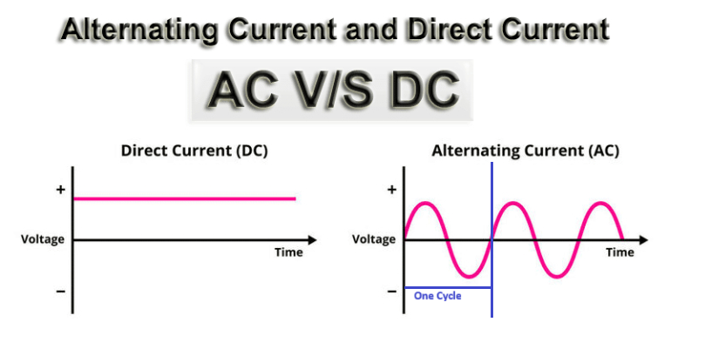

**⚡ Electrical Wire Sizes**

**🔹 1️⃣ Single Phase Supply**

* **Has: 1 Live (Phase 230 Volts) + 1 Neutral + 1 Earth**
* **Voltage: 230V**
* **Used in: Homes, shops, small offices**
* **Has 2 or 3 wires:**
  + **Phase (Live / Line) – carries current**
  + **Neutral – returns current**
  + **Earth – safety**

**⚙️ Voltage: 230V AC**

**📘 Wire Colours (Standard - India):**

| **Function** | **Colour** |
| --- | --- |
| **Phase (Live)** | **Red / Brown** |
| **Neutral** | **Black / Blue** |
| **Earth** | **Green** |

| **Load (Watts)** | **Current (Amps)** | **Wire Size (sq.mm)** | **Example Use** |
| --- | --- | --- | --- |
| **Up to 1000W** | **4–6A** | **1.0 sq.mm** | **Light, fan** |
| **1000–2000W** | **6–10A** | **1.5 sq.mm** | **Mixer, TV** |
| **2000–3000W** | **10–15A** | **2.5 sq.mm** | **Iron box, fridge** |
| **3000–5000W** | **15–20A** | **4.0 sq.mm** | **A.C., washing machine** |
| **5000–7000W** | **25–32A** | **6.0 sq.mm** | **Small office, inverter input** |

**🔹 3️⃣ Three Phase Supply**

* Has: 3 Live (R, Y, B) + 1 Neutral + 1 Earth
* Voltage: 415V
* ⚙️ Reason:  
  The 3 phases are 120° apart, so voltage adds up vectorially → gives 415V (not 690V).
* Used in: Industries, heavy loads, UPS systems
* Has **4 or 5 wires**:
  + **R – Phase 1 (Red)**
  + **Y – Phase 2 (Yellow)**
  + **B – Phase 3 (Blue)**
  + **N – Neutral (Black)**
  + **E – Earth (Green)**

⚙️ **Voltage:** 415V AC (between phases)

| **Load (kW)** | **Current (Amps)** | **Wire Size (sq.mm)** | **Example Use** |
| --- | --- | --- | --- |
| Up to 5 kW | 10–16A | **2.5 sq.mm** | Small motors |
| 5–10 kW | 16–25A | **4.0 sq.mm** | Compressors |
| 10–20 kW | 25–40A | **6.0–10 sq.mm** | 3-phase machines |
| 20–30 kW | 40–60A | **10–16 sq.mm** | Industrial equipment |

**⚙️ In short:**

* **Single Phase = 230V (for homes)**
* **Three Phase = 415V (for industries)**
* **Higher load → thicker wire (bigger sq.mm)**

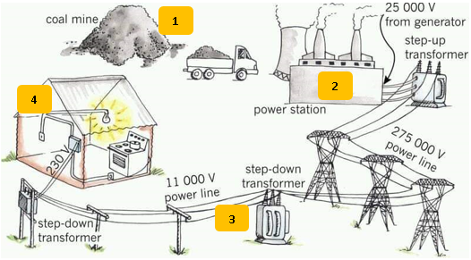

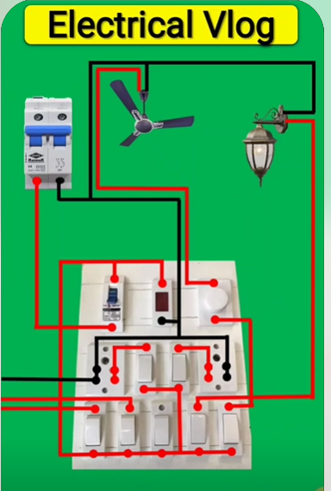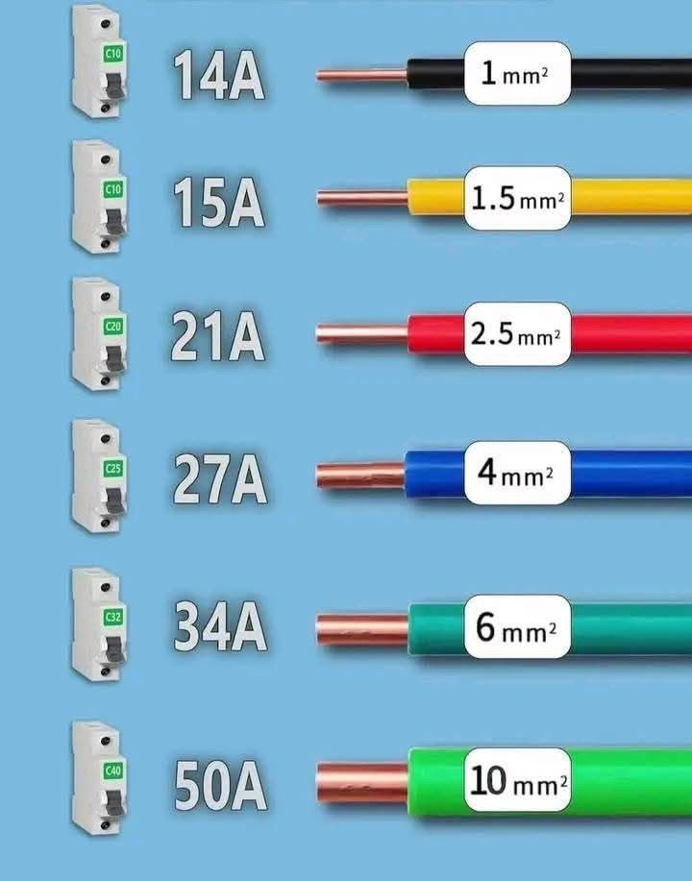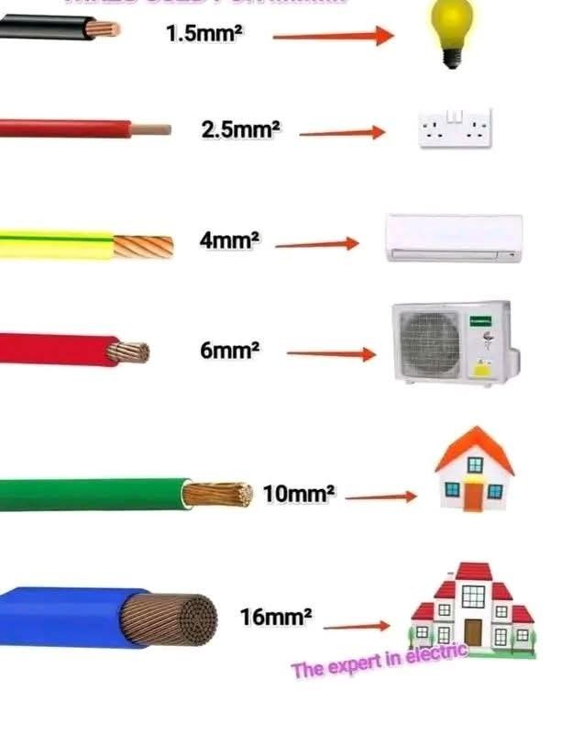

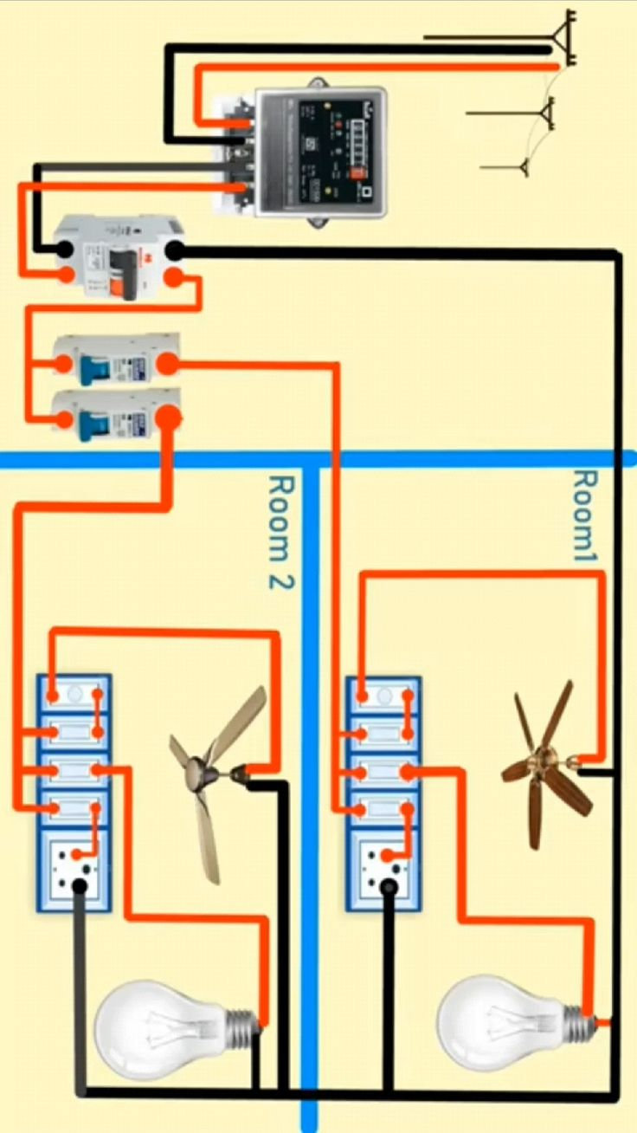

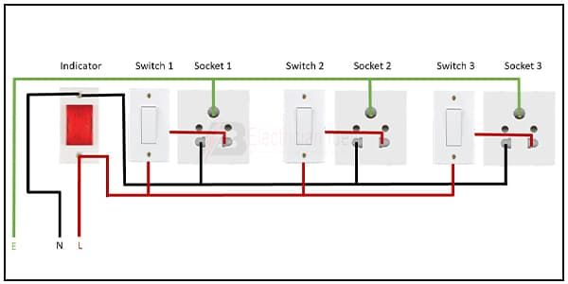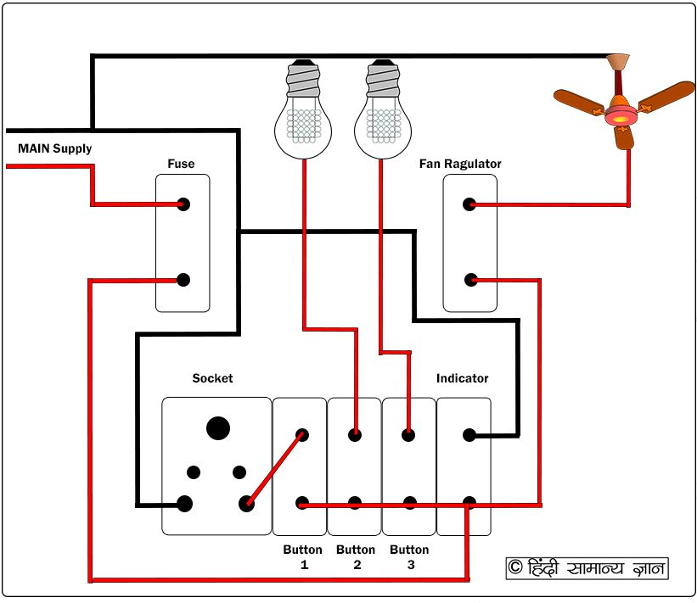

**🔌 Lesson 2: Electronics Components**

**🔹 Definition:**

**Electronics is the study of how electric current flows through small components (like diodes, transistors, ICs) to control, process, or amplify signals.**

**🧠 Simply:**

**Electricity = power flow  
Electronics = control of that power**

**🔹 Main Electronic Components:**

| **Component** | **Symbol** | **Function** | **Example Use** |
| --- | --- | --- | --- |
| **Resistor** |  | Limits or reduces current | Voltage control |
| **Capacitor** |  | Stores and releases electric charge | Power supply filters |
| **Diode** |  | Allows current in one direction only | Rectifiers |
| **LED** |  | Light Emitting Diode | Indicators |
| **Transistor** |  | Works as a switch or amplifier | Motherboard circuits |
| **IC (Integrated Circuit)** |  | Group of small components in one chip | CPU, memory |
| **Relay** |  | Electrically controlled switch | UPS, SMPS |
| **Fuse** |  | Protects circuit from overcurrent | Power protection |
| **Transformer** |  | Changes voltage (step-up/step-down) | Charger, SMPS |

**🔹 Types of Electronic Circuits:**

| **Type** | **Function** | **Example** |
| --- | --- | --- |
| **Analog** | Works with continuous signals | Amplifiers, audio |
| **Digital** | Works with ON/OFF signals (0,1) | Computers, phones |
| **Mixed** | Both analog + digital | SMPS, sound cards |

**🔹 Applications in PC & Laptop:**

* SMPS (Power supply)
* Motherboard circuits
* Laptop charger
* Display and backlight control
* Audio amplifiers
* Battery charging circuits

**💡 In short:**

**Electronics = Controlling electricity using components to make devices work.**

**By Design**

**There are two types of electronic components based on how they are mounted on a circuit board:**

1. **Surface Mounted (SMD) –** These parts sit on the surface of the board. They are small and don’t need holes.
2. **Through-Hole (THD) –** These parts have leads (wires) that go through holes in the board and are soldered on the other side.

**By Working**

**There are two types of components based on what they do:**

1. **Active Components –** These need power to work and can control the flow of electricity.  
   *Examples:* Transistors, Diodes, ICs**.**
2. **Passive Components –** These don’t need power to work and can’t control current; they just store or resist energy.  
   *Examples:* Resistors, Capacitors, Inductors**.**

**⚡ 1. Cold Checking**

**Definition:**Testing or measuring an electronic component or circuit without applying power to it — i.e., the circuit is turned off.

**Purpose:**

* Used to measure resistance, continuity, and component integrity safely.
* Common before powering up a circuit to find faults such as open or short circuits.

**Examples:**

* Measuring the resistance of a resistor using a multimeter (no power connected).
* Checking if a fuse or wire is open or shorted.
* Testing diodes or transistors with the circuit disconnected from power.

**Advantages:**✅ Safe — no electric shock risk.  
✅ Prevents damage to multimeter and circuit.  
✅ Good for quick fault finding.

**🔥 2. Warm Checking**

**Definition:**Testing or measuring components while the circuit is powered ON and operating — i.e., under working (live) conditions.

**Purpose:**

* Used to measure voltage, current, and actual circuit performance.
* Helps identify faults that only appear when the circuit is running (like heating effects, load problems, or voltage drops).

**Examples:**

* Measuring supply voltage across components in a powered circuit.
* Checking voltage gain of an amplifier.
* Measuring current draw of a motor under load.

**Advantages:**✅ Shows real operating behavior of components.  
✅ Helps in troubleshooting dynamic or intermittent faults.

**Caution:**⚠️ Risk of electric shock or component damage if done improperly.  
Always use proper safety precautions and insulated probes.

**🧭 Summary Table:**

| **Type** | **Power Status** | **What You Measure** | **Use For** |
| --- | --- | --- | --- |
| **Cold Checking** | Power OFF | Resistance, continuity | Basic fault finding |
| **Warm Checking** | Power ON | Voltage, current, performance | Live troubleshooting |

**🟫 1. RESISTOR**

**🔹 Definition:**

A resistor is a component that controls or limits the flow of current in a circuit.

**🔹 Identification:**

* **Small cylindrical component with colored bands on the body.**
* **Each color band shows the resistance value.**

**🔹 Value:**

**Measured in Ohms (Ω) using color code or multimeter.  
Formula:**

**V = I × R**

**🔹 Colour Code Table (5-Band Resistor):**

**Resistor colour code table showing how to read 5-band resistors (Ring 1, Ring 2, Ring 3 =digits, Ring 4= multiplier, Ring 5 = tolerance):**

| **Color** | **1st Digit** | **2nd Digit** | **3rd Digit** | **Multiplier** | **Tolerance** |
| --- | --- | --- | --- | --- | --- |
| **Black** | **0** | **0** | **0** | **×1 Ω** | **—** |
| **Brown** | **1** | **1** | **1** | **×10 Ω** | **±1%** |
| **Red** | **2** | **2** | **2** | **×100 Ω** | **±2%** |
| **Orange** | **3** | **3** | **3** | **×1,000 Ω (1 kΩ)** | **—** |
| **Yellow** | **4** | **4** | **4** | **×10,000 Ω (10 kΩ)** | **—** |
| **Green** | **5** | **5** | **5** | **×100,000 Ω (100 kΩ)** | **±0.5%** |
| **Blue** | **6** | **6** | **6** | **×1,000,000 Ω (1 MΩ)** | **±0.25%** |
| **Violet** | **7** | **7** | **7** | **×10,000,000 Ω (10 MΩ)** | **±0.1%** |
| **Gray** | **8** | **8** | **8** | **×100,000,000 Ω** | **±0.05%** |
| **White** | **9** | **9** | **9** | **×1,000,000,000 Ω** | **—** |
| **Gold** | **—** | **—** | **—** | **×0.1 Ω** | **±5%** |
| **Silver** | **—** | **—** | **—** | **×0.01 Ω** | **±10%** |
| **No band** | **—** | **—** | **—** | **—** | **±20%** |

**Example (5-band):**

**Red (2) — Violet (7) — Black (0) — Brown (×10) — Brown (±1%)**

**→ Resistance = 270 × 10 = 2700 Ω = 2.7 kΩ ±1%**

**Example:  
Red (2) – Violet (7) – Brown (×10) → 27 × 10 = 270Ω ±5%**

* Red (2)
* Violet (7)
* Orange (×1 000)
* Gold (±5%)

→ 27 × 1 000 = 27 000 Ω = 27 kΩ ± 5%

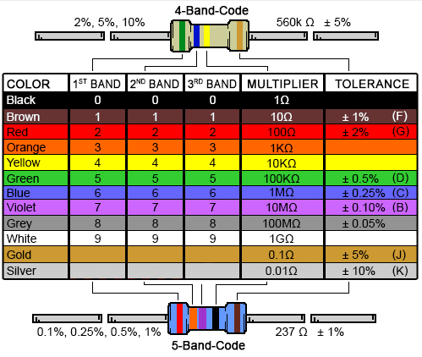

**🧠 Mnemonic (classic student version)**

👉 **“BB ROY of Great Britain had a Very Good Wife.”**

Each capital letter = colour5 initial:  
**B**lack, **B**rown, **R**ed, **O**range, **Y**ellow, **G**reen, **B**lue, **V**iolet, **G**ray, **W**hite.

**🔹 Types:**

1. **Fixed Resistor – Fixed value (Carbon, Metal film)**
2. **Variable Resistor (Potentiometer) – Adjustable**
3. **LDR (Light Dependent Resistor) – Changes with light**

**🔹 Working:**

**Resists the flow of current to control voltage or current in the circuit.**

**🔹 Checking:**

**✅ Use a Mustimeter (set to Ohm range)**

* Touch probes to both ends
* Display shows value in Ω, KΩ, or MΩ
* Infinite = open (faulty)

**✅ GOOD**

* The component is working properly.
* It shows **the correct value** (resistance, voltage, etc.).
* Example: A 1 kΩ resistor reads close to 1 kΩ.

**❌ OPEN**

* The component is broken inside — there is no connection.
* The meter shows infinite resistance (OL) or **no reading.**
* Example: A resistor reads “OL” — current cannot pass through.

**⚡ SHORTED**

* The component’s two ends are touching directly (no resistance).
* The meter shows 0 Ω or **very low resistance**.
* Example: A resistor or wire that reads “0 Ω” — current flows freely (short circuit).

**🔹 Soldering / Desoldering:**

* **Soldering: Place resistor lead through hole, heat with iron, add solder.**
* **Desoldering: Use solder wick or sucker pump to remove solder and lift component**

**⚡ 2. CAPACITOR**

**🔹 Definition:**

Stores electric charge and releases it when needed and also charging and discharging. It is denoted with “C” lettelr

**🔹 Identification:**

* Has two leads, value printed on body (e.g., 100µF, 25V).
* Electrolytic capacitors have + and – polarity.

**🔹 Value:**

Measured in Farads (F) – usually µF (microfarad) or pF (picofarad).

**🔹 Types:**

1. Electrolytic – Large, polarized
2. Ceramic Disc – Small, non-polar
3. Tantalum, Film, SMD – For compact circuits
4. Paper Capacitor
5. Ceramic Capacitor
6. Disc Capacitor
7. Polyester Capacitor
8. Polarized
9. Non-Polarized

**🔹 Working:**

Stores DC charge and blocks AC — used for filtering, timing, smoothing.

**🔹 Checking:**

* We check is it charging & Discharging
* Use multimeter capacitance mode
* Or in resistance mode → meter shows charging (value rising) → good
* Constant reading = short, no reading = open

**🔹 Soldering:**

**Same as resistor — but be careful with polarity (– side marked).**

**🔺 3. DIODE**

**🔹 Definition:**

**Allows current to flow in one direction only.**

**🔹 Identification:**

* **Has black body with silver band on one side (cathode).**
* **Symbol: ➤|—**

**🔹 Working:**

**Conducts when forward-biased, blocks when reverse-biased.**

**🔹 Checking:**

**Use multimeter diode mode**

* **Forward: 0.5–0.7V = good**
* **Reverse: no reading = good**

**🔹 Types:**

* **Rectifier diode (e.g., 1N4007)**
* **Zener diode (for voltage regulation)**
* **LED (Light Emitting Diode)**

**🧩 4. TRANSISTOR**

**🔹 Definition:**

**Works as a switch or amplifier.**

**🔹 Identification:**

* **3 legs: Base (B), Collector (C), Emitter (E)**
* **Type printed (e.g., BC547, 2N2222)**

**🔹 Types:**

1. **NPN**
2. **PNP**

**🔹 Working:**

**Small current at base controls large current from collector → emitter.**

**🔹 Checking:**

* **Use multimeter in diode mode**
* **Check Base–Emitter and Base–Collector junctions (both 0.6–0.7V)**
* **Reverse side should show open.**

**🧠 5. IC (Integrated Circuit)**

**🔹 Definition:**

**An IC is a chip that contains many small components (transistors, resistors, capacitors) inside one package.**

**🔹 Identification:**

* **Black rectangular chip with pins on sides.**
* **Has a dot or notch marking Pin 1.**

**🔹 Working:**

**Performs a complete function like amplification, control, or memory.**

**🔹 Checking:**

**Hard to check individually — verify input/output voltage using datasheet or oscilloscope.**

**🔧 6. SOLDERING & DESOLDERING TIPS**

| **Step** | **Tool** | **Note** |
| --- | --- | --- |
| **Soldering** | Soldering Iron (25–40W) | Clean tip, apply solder quickly |
| **Desoldering** | Pump / Wick | Heat joint and remove solder |
| **Safety** | Use stand, don’t touch tip, work in ventilated area |  |

**🌀 COIL (INDUCTOR)**

**🔹 Definition:**

A coil, also called an inductor, is a component made by winding copper wire around a core.  
It stores energy in a magnetic field when current passes through it.

🧠 Simple meaning:

A coil blocks sudden changes in current and helps in filtering and power control.

**🔹 Identification:**

* Looks like a copper wire wound on a circular core (air, iron, or ferrite).
* On PC boards, may look like a small ring (toroid) or black square block (SMD type).
* Usually marked with L1, L2, L3… on the circuit board.

**🔹 Value:**

* Measured in Henry (H).  
  (Common values: mH = millihenry, µH = microhenry)
* Example: 100µH, 2.2mH

**🔹 Types of Coils / Inductors:**

| **Type** | **Description** | **Use** |
| --- | --- | --- |
| **Air-core coil** | **No metal inside** | **Radio, tuning circuits** |
| **Iron-core coil** | **Iron rod inside** | **Transformers** |
| **Ferrite-core coil** | **Ferrite core** | **SMPS, filters** |
| **SMD coil** | **Small surface-mount** | **Laptop motherboards** |

**🔹 Working:**

* When current flows, a magnetic field is created around the coil.
* If current changes suddenly, coil opposes that change.
* Used for filtering, energy storage, tuning and reducing noise.

**🔹 Checking:**

**✅ Use a multimeter (Ohm range):**

* Good coil → shows low resistance (few ohms)
* Open reading (∞) → coil is broken
* If shorted → shows 0 ohms

**🧰 For more accuracy → use LCR meter to check inductance value.**

**🔹 Soldering / Desoldering:**

* Solder quickly, don’t overheat — coil wire is thin and can burn.
* For desoldering, use solder wick or pump, and lift carefully to avoid pulling the winding.

**⚙️ Applications:**

* SMPS (Power supply filters)
* Laptop charger circuits
* Motherboard VRM section
* Audio filters
* Transformers (coils + cores)

**🌡️ 1. THERMISTOR**

**🔹 Definition:**

**A Thermistor is a temperature-sensitive resistor —  
its resistance changes when temperature changes.**

**🧠 *Simple meaning:* It senses heat.**

**🔹 Identification:**

* **Small round or bead-shaped component.**
* **Marked as TH1, TH2… on the circuit board.**
* **Often black, blue, or green in color.**

**🔹 Types of Thermistors:**

1. **NTC (Negative Temperature Coefficient)  
   → Resistance decreases as temperature increases.  
   🧩 *Used in:* Power supply circuits, temperature sensors, battery charging.**
2. **PTC (Positive Temperature Coefficient)  
   → Resistance increases as temperature increases.  
   🧩 *Used in:* Overcurrent protection, motor winding protection.**

**🔹 Working:**

* **When temperature rises, resistance changes (depends on NTC or PTC type).**
* **Circuit senses this change to control fan speed, cutoff, or temperature alarm.**

**🔹 Checking (Multimeter):**

* **Measure resistance (Ω range).**
* **Heat it slightly (with finger or heat gun):**
  + **If resistance drops → NTC**
  + **If resistance rises → PTC**

**🔹 Applications:**

* **Power supply protection**
* **Laptop battery temperature sensor**
* **SMPS inrush current control**
* **Fan and air-conditioner sensors**

**⚡ 2. VDR (Voltage Dependent Resistor) / VARISTOR**

**🔹 Definition:**

**A VDR (or MOV – Metal Oxide Varistor) protects circuits from high voltage spikes (surge protection).**

**🧠 *Simple meaning:***

**Works like a “voltage guard”.**

**🔹 Identification:**

* Round disc-shaped component (blue or orange).
* Marked like MOV-14D471K (means 470V rating).
* Connected between Phase & Neutral.

**🔹 Working:**

* At normal voltage → high resistance (acts open).
* When voltage rises suddenly → low resistance, absorbs extra voltage → protects circuit.

**🔹 Checking:**

* Normally shows infinite resistance on multimeter.
* If shorted (0Ω) → it’s burnt or damaged.

**🔹 Use:**

* **In SMPS, chargers, laptops, AC boards, TV power supply.**

**💡 3. LDR (Light Dependent Resistor)**

**🔹 Definition:**

**An LDR changes its resistance based on light intensity.**

**🧠 *Simple meaning:***

**More light → less resistance  
Dark → more resistance**

**🔹 Identification:**

* Round, light-brown surface with zig-zag track on top.
* Marked as LDR1, LDR2...

**🔹 Working:**

* Works as a light sensor.
* When light falls on it → resistance drops → current increases.

**🔹 Checking:**

* Use multimeter (Ohm range).
* In dark → high resistance (100KΩ or more).
* In bright light → low resistance (few KΩ).

**🔹 Use:**

* Automatic street lights
* Light sensors in mobile, laptops
* Security systems, solar lights

**🔧 4. PTC & NTC (Quick Summary Table)**

| **Type** | **Full Form** | **Temperature ↑** | **Resistance** | **Used For** |
| --- | --- | --- | --- | --- |
| **PTC** | Positive Temperature Coefficient | Increases | Increases | Overload protection, degaussing, sensors |
| **NTC** | Negative Temperature Coefficient | Increases | Decreases | Temperature sensing, inrush current control |

**🧠 In short:**

| **Component** | **Depends On** | **Function** | **Used In** |
| --- | --- | --- | --- |
| **Thermistor (NTC/PTC)** | Temperature | Sense or limit heat/current | SMPS, batteries |
| **VDR / MOV** | Voltage | Protects from surge | Power supply |
| **LDR** | Light | Sense light level | Street lights, sensors |

**⚡ Transformer**

**🔹 Definition:**

**A Transformer is an electrical device used to increase (step-up) or decrease (step-down) the AC voltage without changing the frequency.**

**🔹 Working Principle:**

**It works on the principle of electromagnetic induction —  
when AC current flows through the primary coil, it creates a magnetic field that induces voltage in the secondary coil.**

**🔹 Main Parts:**

1. Primary Coil – connected to input AC supply.
2. Secondary Coil – connected to the output/load.
3. Iron Core – links magnetic field between both coils.

**🔹 Types of Transformers:**

1. Step-Up Transformer – increases voltage, decreases current.
2. Step-Down Transformer – decreases voltage, increases current.
3. Isolation Transformer – transfers power without changing voltage (for safety).

**🔹 Formula:**

$$\frac{V_{1}}{V_{2}}=\frac{N_{1}}{N_{2}}$$

**Where,**

* V₁ = Primary Voltage
* V₂ = Secondary Voltage
* N₁ = No. of turns in primary coil
* N₂ = No. of turns in secondary coil

**🔹 Checking Method:**

1. Use a multimeter to check coil continuity (resistance).
2. Primary & Secondary coils should show resistance — *not open*.
3. If open, coil is burnt.
4. Check input & output voltage if power is ON.

**🔹 Uses:**

* **Used in power supplies, chargers, UPS, SMPS, TV, laptops, etc.**

**Top of Form**

**⚡ Types of Transformers (Based on Taps)**

**🔹 1. Tapped Transformer**

* A transformer that has extra connection points (taps) on its winding.
* These taps allow you to change output voltage levels.
* Example: 0V – 9V – 12V – 15V transformer.

🧠 Use: To get different voltages from a single transformer.

**🔹 2. Center-Tapped Transformer**

* The secondary winding has a middle connection (tap at center).
* This gives two equal voltages —
* one positive and one negative with respect to the center point.

⚙️ Example: 12V–0–12V transformer gives +12V and –12V.

🧠 Use: Used in rectifiers (Full-wave center-tap type) and power supplies.

**🔹 3. Multi-Tapped Transformer**

* Similar to a tapped transformer, but has many taps on secondary winding.
* Each tap gives a different voltage output (like 3V, 6V, 9V, 12V, etc).
* Allows flexibility in voltage selection.

🧠 Use: In testing equipment, chargers, and variable voltage power supplies.

**🔹 4. Auto Transformer**

* Has only one coil, used as both primary and secondary.
* A variable tap is taken along the winding to adjust the output voltage.
* Smaller, cheaper, and lighter than normal transformers.

🧠 Use: In voltage regulators, variacs, and stabilizers.

**⚙️ Simple Difference Table**

| **Type** | **No. of Windings** | **Tap Position** | **Output Control** | **Common Use** |
| --- | --- | --- | --- | --- |
| **Tapped** | 2 | Few taps | Fixed | Power supply |
| **Center-Tapped** | 2 | Middle of secondary | Fixed | Full-wave rectifier |
| **Multi-Tapped** | 2 | Many points | Selectable | Test bench, chargers |
| **Auto** | 1 (common) | Adjustable slider | Variable | Voltage control, stabilizer |

**Bottom of Form**

**⚡ UPS (Uninterruptible Power Supply)**

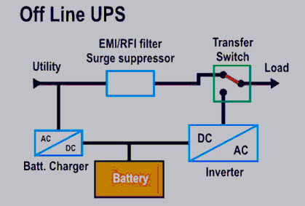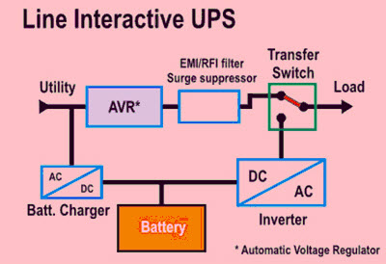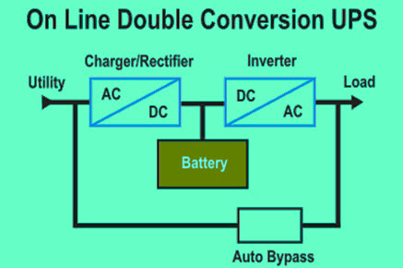

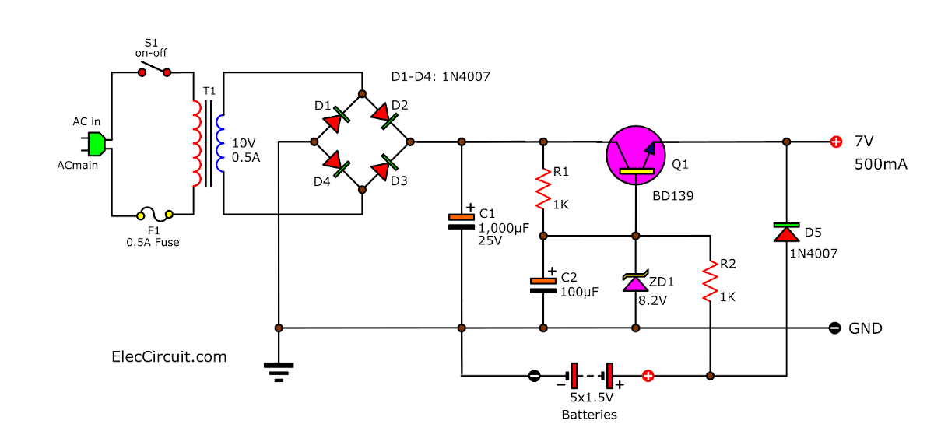

**🔹 Definition:**

A UPS is an electrical device that provides backup power to your computer or system when the main power fails or fluctuates.

It ensures continuous operation and protects devices from data loss or damage caused by power cuts**.**

**🔹 Main Functions:**

1. Gives instant power backup during power failure.
2. Regulates voltage — protects against surges or drops.
3. Prevents data loss and hardware damage.

**🔹 Main Parts:**

1. Rectifier / Charger – converts AC → DC to charge the battery.
2. Battery – stores DC power.
3. Inverter – converts DC → AC to supply power to devices.
4. Static Switch / Relay – instantly switches between mains and battery.

**🔹 Types of UPS:**

| **Type** | **Working** | **Use / Advantage** |
| --- | --- | --- |
| **1. Offline / Standby UPS** | Works only when power fails. | Low cost, for home PCs. |
| **2. Line-Interactive UPS** | Regulates voltage during fluctuations. | Common in offices. |
| **3. Online UPS** | Always supplies power through inverter. | High protection, for servers and hospitals. |

**🔹 Working Principle:**

* When AC power is ON → UPS charges the battery and supplies power directly to devices.
* When AC power fails → UPS instantly switches to battery power (within milliseconds).

**🔹 Checking / Maintenance:**

1. Check battery voltage with a multimeter.
2. Inspect charging circuit and inverter output.
3. Keep battery terminals clean and charge regularly.

**🔹 Common Uses:**

* Computers / Laptops
* Servers
* Routers / CCTV
* Medical equipment
* ATM machines

**⚡ DIODE**

**🔹 Definition:**

**A Diode is an electronic component that allows current to flow in only one direction — from Anode (+) to Cathode (–).  
It acts like a one-way valve for electricity.**

**🔹 Symbol:**

**→|─**

* **Arrow (→) = Current flow direction (Anode → Cathode)**
* **Line (|) = Cathode side (negative)**

**🔹 Terminals:**

1. **Anode (+) — Positive terminal**
2. **Cathode (–) — Negative terminal (marked with a silver/white band)**

**🔹 Working:**

* **When the Anode is more positive than Cathode, diode conducts (Forward Bias).**
* **When Cathode is more positive, diode blocks current (Reverse Bias).**

**🔹 Types of Diodes:**

| **Type** | **Function** | **Example Use** |
| --- | --- | --- |
| **1. PN Junction Diode** | Allows current in one direction | Rectifiers |
| **2. Zener Diode** | Regulates voltage (fan regulator) | Power supply |
| **3. LED (Light Emitting Diode)** | Emits light when current passes | Indicators |
| **4. Photo Diode** | Detects light | Sensors |
| **5. Schottky Diode** | Fast switching | SMPS, high-speed circuits |
| **6. Varactor Diode** | Works as variable capacitor | Tuners |

**🔹 Checking with Multimeter:**

1. Set multimeter to Diode mode.
2. Connect Red → Anode and Black → Cathode → reading shows (0.6–0.7 V for silicon).
3. Reverse the probes → no reading → diode is good.
4. Reading both sides → diode shorted.
5. No reading both sides → diode open.

**🔹 Uses:**

* **Rectifiers (convert AC to DC)**
* **Voltage regulators**
* **Protection circuits**
* **LEDs and displays**

**🔹 Uses:**

* **Red lead → Anode**
* **Black lead → Cathode**

| **Condition** | **Multimeter Reading (Red → Anode, Black → Cathode)** | **Reverse (Red → Cathode, Black → Anode)** | **Diode Status** | **Remarks** |
| --- | --- | --- | --- | --- |
| **Good diode** | 0.5 V – 0.8 V (for silicon diode)  ~0.2 V – 0.3 V (for germanium diode) | OL (no conduction) | ✅ Good | Forward-biased ✅ shows voltage drop, reverse-biased ❌ blocks current |
| **Open diode** | OL (no conduction) | OL (no conduction) | ❌ Open | No current flow in either direction❌ |
| **Shorted diode** | 0 V or very low (≈0 Ω) | 0 V or very low (≈0 Ω) | ❌ Shorted | Conducts in both directions ✅ |

**W**

**⚡ TRANSISTOR**

**🔹 Definition:**

**A Transistor is a semiconductor device used to amplify or switch electronic signals and power.  
It acts like an electronic switch or signal booster.**

**🔹 Symbol and Terminals:**

**There are 3 terminals in a transistor:**

1. **Base (B) – controls the transistor**
2. **Collector (C) – input side (current enters)**
3. **Emitter (E) – output side (current leaves)**

**🔸 Symbols:**

**NPN Type:**

**C**

**|**

**|\**

**Base--| >---- E**

**|**

**PNP Type:**

**C**

**|**

**|/**

**Base--| <---- E**

**|**

**🧠 Arrow always points from P → N (shows current flow direction).**

**🔹 Types of Transistors:**

| **Type** | **Full Form** | **Function** | **Example** |
| --- | --- | --- | --- |
| **1. NPN** | Negative–Positive–Negative | Common type, current flows when base gets +ve | BC547, 2N2222 |
| **2. PNP** | Positive–Negative–Positive | Current flows when base gets –ve | BC557 |

**🔹 Working Principle:**

**A small base current controls a large collector current.**

**💡 Think:**👉 Base = switch button  
👉 Collector–Emitter = main circuit  
When you press the button (give base current), current flows through the main path.

**🔹 Main Uses:**

1. Switching circuits (turn ON/OFF devices)
2. Amplifiers (increase signal strength)
3. Voltage regulators
4. Signal control in computers and SMPS

**🔹 Testing with Multimeter:**

1. Keep multimeter in diode mode.
2. Identify Base terminal (shows voltage drop with both other pins).
3. For NPN → Base positive shows 0.6–0.7 V to C & E.
4. For PNP → Base negative shows 0.6–0.7 V to C & E.
5. No readings or both sides short → transistor faulty.

**🔹 Important Note:**

* Transistors are used in motherboards, chargers, power sections, and signal circuits.
* Modern laptops use MOSFETs — an advanced type of transistor.

**⚡ Transistor Testing Using Multimeter (Diode Mode)**

**🔸 Transistor has 3 pins:**

**👉 B – Base  
👉 C – Collector  
👉 E – Emitter**

**🧩 1. NPN Transistor**

**➡ Multimeter Setting: Diode Mode**

| **Step** | **Red Probe** | **Black Probe** | **Expected Reading** | **Result** |
| --- | --- | --- | --- | --- |
| **1** | Base (B) | Collector (C) | 0.6V–0.7V | ✅ (Forward) |
| **2** | Base (B) | Emitter (E) | 0.6V–0.7V | ✅ (Forward) |
| **3** | Collector (C) | Base (B) | No Reading | ✅ (Reverse Block) |
| **4** | Emitter (E) | Base (B) | No Reading | ✅ (Reverse Block) |
| **5** | Collector (C) | Emitter (E) | No Reading | ✅ (Open) |

✅ If readings are as above → NPN is good.  
❌ If short or no readings at all → faulty.

**🧩 2. PNP Transistor**

**➡ Multimeter Setting: Diode Mode**

| **Step** | **Red Probe** | **Black Probe** | **Expected Reading** | **Result** |
| --- | --- | --- | --- | --- |
| **1** | Collector (C) | Base (B) | 0.6V–0.7V | ✅ (Forward) |
| **2** | Emitter (E) | Base (B) | 0.6V–0.7V | ✅ (Forward) |
| **3** | Base (B) | Collector (C) | No Reading | ✅ (Reverse Block) |
| **4** | Base (B) | Emitter (E) | No Reading | ✅ (Reverse Block) |
| **5** | Collector (C) | Emitter (E) | No Reading | ✅ (Open) |

**✅ If readings are as above → PNP is good.  
❌ If short or open both sides → faulty.**

**🔹 Easy Memory Tip:**

* NPN → Base Positive (Red = Base)
* PNP → Base Negative (Black = Base)

**⚡ IC (Integrated Circuit)**

**🔹 Definition:**

**An IC (Integrated Circuit) is a small electronic chip made of semiconductors that contains many components like transistors, resistors, capacitors, and diodes all built into one tiny package.**

**🧠 In simple words:  
👉 IC = Complete circuit in a single chip.**

**🔹 Function:**

* **Performs processing, amplification, control, and power regulation depending on its design.**
* **Used in motherboards, chargers, BIOS chips, CPUs, RAM, and SMPS.**

**🔹 Types of ICs:**

| **Type** | **Full Form** | **Function / Use** |
| --- | --- | --- |
| **1. Analog IC** | **Works with continuous signals** | **Audio amps, sensors** |
| **2. Digital IC** | **Works with binary (0 & 1) signals** | **Microprocessor, memory** |
| **3. Mixed IC** | **Both analog + digital** | **Power control, communication** |
| **4. Linear IC** | **Gives output proportional to input** | **Operational amplifiers (Op-amp)** |
| **5. Power IC** | **Handles high current/voltage** | **Power supply circuits, SMPS** |

**🔹 Common IC Packages:**

| **Type** | **Shape** | **Pins** |
| --- | --- | --- |
| **DIP (Dual Inline Package)** | **Rectangle, two side pins** | **8, 14, 16 pins** |
| **SMD (Surface Mount Device)** | **Flat, small, for PCB mounting** | **8 to 100+ pins** |
| **SIP (Single Inline Package)** | **One side pins** | **Few pins only** |

**🔹 Pin Identification:**

* **The small dot or notch on the IC shows Pin 1.**
* **Pin numbers increase anti-clockwise from that point.**

**🔹 Checking IC:**

* **ICs are complex — can’t test fully with a multimeter.**
* **You can check input/output voltage on circuit.**
* **If IC overheats, or no output voltage, it may be shorted or dead.**
* **Sometimes replaced using hot air gun (SMD rework).**

**🔹 Applications:**

* **Microprocessor (CPU)**
* **Memory (RAM, ROM, BIOS)**
* **Amplifiers & Audio circuits**
* **Voltage regulators (e.g., LM7805)**
* **Logic gates, timers (e.g., IC 555)**
* **Laptop power chips, charging ICs**

**🔹 Advantages:**

**✅ Small size  
✅ Low power use  
✅ High speed  
✅ Reliable and durable**

**⚙️ Short Table:**

| **Type** | **Controls** | **Use** | **Example** |
| --- | --- | --- | --- |
| **SP (Single Pole)** | 1 phase only | Light switch | Room light |
| **DP (Double Pole)** | Phase + Neutral | Socket / UPS | Power switch |
| **TP (Triple Pole)** | 3 Phases | Motor, 3-phase load | Industrial use |
| **4P (Four Pole)** | 3 Phase + Neutral | Main MCB | Panel board |

**⚡ Regulated Power Supply (RPS)**

**🔹 Definition:**

**A Regulated Power Supply is a circuit that gives a constant, stable DC voltage even if the input voltage or load current changes.**

**🧠 In simple words:  
👉 It converts AC → DC and keeps the voltage steady for electronic circuits.**

**🔹 Block Diagram:**

**AC Input → Transformer → Rectifier → Filter → Voltage Regulator → DC Output**

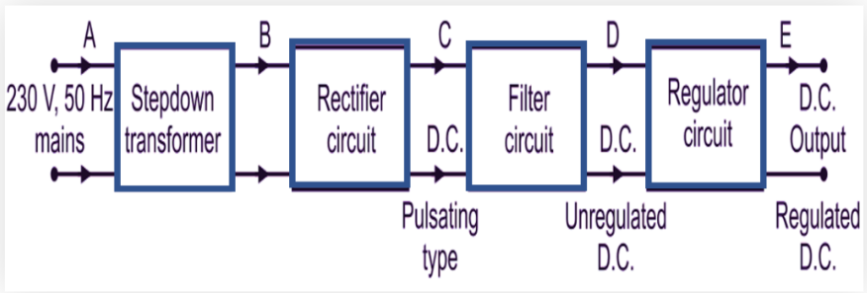

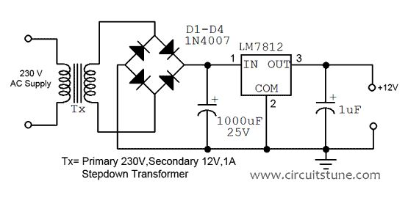

**🔹 Main Parts:**

| **Part** | **Function** |
| --- | --- |
| **1. Transformer** | **Steps down high AC voltage (230V → 12V or 9V).** |
| **2. Rectifier (Diodes)** | **Converts AC to pulsating DC.** |
| **3. Filter (Capacitor)** | **Removes AC ripples to smooth DC.** |
| **4. Voltage Regulator IC** | **Keeps output voltage constant.** |
| **5. Load** | **The device using the power (e.g., circuit board).** |

**🔹 Types of Power Supply:**

| **Type** | **Description** | **Example** |
| --- | --- | --- |
| **1. Unregulated** | **Output varies with load** | **Simple adapter** |
| **2. Regulated** | **Output stays fixed** | **RPS, SMPS** |

**🔹 Common Voltage Regulator ICs:**

| **IC** | **Output Voltage** | **Type** |
| --- | --- | --- |
| **LM7805** | **+5V** | **Positive regulator** |
| **LM7812** | **+12V** | **Positive regulator** |
| **LM7905** | **–5V** | **Negative regulator** |
| **LM317** | **Adjustable** | **Variable regulator** |

**🔹 Working:**

1. **AC input (230V) → step down using Transformer.**
2. **Rectifier (diodes) convert AC → DC.**
3. **Filter capacitor smoothens DC.**
4. **Regulator IC maintains fixed DC output (e.g., +5V).**

**🔹 Output Formula (for LM317):**

$$V_{out}=1.25(1+\frac{R2}{R1})$$

**🔹 Uses:**

* **Used in testing electronic circuits.**
* **Motherboard service bench power.**
* **SMPS and chargers.**
* **Microcontroller / IC testing.**

**🔹 Advantages:**

**✅ Stable voltage  
✅ Protects components  
✅ Low noise  
✅ Reliable operation**

**🔧 Multimeter**

**🔹 Definition:**

**A Multimeter is an electronic measuring instrument that can measure Voltage, Current, Resistance, and other parameters like diode, continuity, hFE (transistor gain), etc.**

**👉 It is also called a Volt-Ohm-Milliammeter (VOM).**

**🔹 Types of Multimeters:**

1. **Analog Multimeter – Uses needle display.**
2. **Digital Multimeter (DMM) – Shows readings on LCD display (common in PC/laptop service).**

**🔹 Main Functions of a Digital Multimeter:**

| **Function** | **Symbol** | **Purpose** | **Example Reading** |
| --- | --- | --- | --- |
| **DC Voltage** | **V⎓ or V–** | **Measures battery or DC supply voltage** | **5V, 12V, etc.** |
| **AC Voltage** | **V~** | **Measures mains voltage** | **230V AC** |
| **DC Current** | **A⎓ or A–** | **Measures current flow in DC circuits** | **0.5A** |
| **AC Current** | **A~** | **Measures current flow in AC circuits** | **1A** |
| **Resistance** | **Ω** | **Measures resistance of components** | **220Ω, 10kΩ** |
| **Continuity Test** | **🔔 or sound symbol** | **Checks if wire or circuit is connected** | **Beep = connected** |
| **Diode Test** | **▶** | **–** | **Checks diode forward/reverse condition** |
| **hFE (Transistor Test)** | **hFE socket** | **Measures transistor gain** | **Value like 100–400** |
| **Non-connectivity (Open)** | **—** | **When no beep or ∞ reading → circuit open** | **Broken wire** |

**🔹 How to Use Each Function:**

**🟢 1. DC Voltage (V⎓):**

* Turn knob to “DCV”.
* Connect Red probe → +, Black → –.
* Use to test batteries, adapters, SMPS outputs.

**🔵 2. AC Voltage (V~):**

* Turn knob to “ACV”.
* Test mains supply (230V).  
  ⚠️ Be careful — use insulated probes.

**🟡 3. Resistance (Ω):**

* Turn knob to “Ω” range.
* Touch both ends of resistor/wire.
* Shows resistance value.

**🔴 4. Continuity Test (🔔):**

* Touch both probes across wire or path.
* Beep sound = connected.
* No beep = wire broken or open circuit.

**⚪ 5. Diode Test (▶|–):**

* Connect Red to Anode (+), Black to Cathode (–).
* Reading ~0.6V = diode good.
* No reading (OL) = open diode.

**🟣 6. hFE (Transistor Gain):**

* Insert transistor legs (E, B, C) into correct sockets.
* Multimeter shows transistor gain value (hFE).

**⚫ 7. Current Measurement (A⎓ or A~):**

* Move red probe to A socket.
* Connect meter in series with circuit.
* Shows current in Amperes.

**⚙️ 8. Non-Connectivity (Open):**

* If no beep or ∞ (infinity) shown → circuit open.
* Used to find broken traces or wires.

**🔹 Safety Tips:**

* **Always start with highest range.**
* **Never measure AC current directly unless meter supports it.**
* **Don’t touch probe metal while testing live AC.**
* **Disconnect power when checking resistance or continuity.**

**🔹 Uses in PC Hardware / Laptop Service:**

* **Check SMPS 12V, 5V outputs.**
* **Test charger adapter voltage.**
* **Check motherboard short circuit (continuity).**
* **Test diodes, transistors, MOSFETs.**
* **Verify power jack, USB port, fan supply.**

**🔧 SOLDERING**

**🔹 Definition:**

**Soldering is the process of joining two or more metal parts (usually wires or electronic components) by melting a filler metal (solder) at a low temperature.**

**👉 The solder melts and sticks to the parts, creating a strong electrical and mechanical connection.**

**🔹 Tools Required:**

| **Tool** | **Use** |
| --- | --- |
| **Soldering Iron** | **Heats the solder to melt it** |
| **Solder Wire** | **Filler metal (usually Tin + Lead or Lead-free alloy)** |
| **Soldering Stand** | **Holds the hot iron safely** |
| **Sponge / Brass Wool** | **Cleans the iron tip** |
| **Flux / Paste** | **Removes oxide and improves solder flow** |
| **Tweezers** | **Holds small components** |
| **Desoldering Pump / Wick** | **Used to remove solder (for rework)** |

**🔹 Soldering Materials:**

| **Material** | **Description** |
| --- | --- |
| **Solder Wire** | **60% Tin + 40% Lead (common), or Lead-free type** |
| **Flux** | **Helps solder stick properly** |
| **Solder Paste** | **Used for SMD components (chip-level work)** |

**🔹 Types of Soldering:**

| **Type** | **Description** | **Use** |
| --- | --- | --- |
| **Soft Soldering** | **Below 450°C** | **For electronics** |
| **Hard Soldering** | **Above 450°C** | **For mechanical joints** |
| **Wave / Reflow Soldering** | **Automatic method** | **Used in PCB manufacturing** |

**🔹 Steps in Soldering:**

1. **Clean the surface — remove dust/oxide.**
2. **Apply flux to improve contact.**
3. **Heat with soldering iron.**
4. **Touch solder wire to joint (not to the iron directly).**
5. **Allow solder to flow smoothly.**
6. **Remove heat and let it cool naturally.**
7. **Check for shiny, clean joint (dull = cold solder).**

**🔹 Good vs Bad Solder Joint:**

| **Type** | **Appearance** | **Result** |
| --- | --- | --- |
| **✅ Good Joint** | **Shiny, smooth, cone shape** | **Strong, conducts well** |
| **❌ Cold Joint** | **Dull, cracked, lumpy** | **Weak, poor connection** |

**🔹 Safety Tips:**

* **Never touch iron tip (very hot ~350°C).**
* **Work in ventilated area (fumes).**
* **Keep soldering stand ready.**
* **Don’t drop molten solder on PCB or body.**

**🔹 Use in Laptop/PC Service:**

* **Replace damaged connectors, ICs, SMD components.**
* **Re-solder broken tracks or pins.**
* **Use flux and thin wire for chip-level work.**
* **Use hot air gun + solder paste for SMD rework.**

**⚡ RECTIFIER**

**🔹 Definition:**

**A Rectifier is an electronic circuit that converts AC (Alternating Current) into DC (Direct Current) using diodes.**

**💡 *AC changes direction, DC flows in one direction.***

**1️⃣ Half Wave Rectifier**

**🔹 Circuit:**

* **Uses 1 diode**
* **AC → Transformer → 1 Diode → Load → Output**

**🔹 Working:**

* **The diode conducts only during one half cycle (positive) of AC.**
* **Negative half is blocked → no current.**

**🔹 Output:**

**→ Pulsating DC (only half of AC used)**

**🔹 Advantages:**

**✅ Simple and low cost**

**🔹 Disadvantages:**

**❌ Low efficiency  
❌ Ripple (not smooth DC)**

**🔹 Diagram Summary:**

**AC**

**|**

**[DIODE] → Positive half only → DC output**

**2️⃣ Full Wave Rectifier (Center-Tapped Type)**

**🔹 Circuit:**

* **Uses 2 diodes**
* **Center-tapped transformer (two equal halves)**

**🔹 Working:**

* **One diode conducts during the positive half**
* **The other diode conducts during the negative half**
* **So, both halves of AC are used.**

**🔹 Output:**

**→ Continuous pulsating DC (more smooth)**

**🔹 Advantages:**

**✅ Better efficiency  
✅ Less ripple than half-wave**

**🔹 Disadvantages:**

**❌ Requires center-tapped transformer**

**🔹 Diagram Summary:**

**---|>|---+**

**AC → CT → Load**

**---|<|---+**

**3️⃣ Bridge Rectifier**

**🔹 Circuit:**

* **Uses 4 diodes arranged in bridge form**
* **No need for center tap**

**🔹 Working:**

* **During both half cycles, current flows in same direction through the load.**
* **All 4 diodes work in pairs alternately.**

**🔹 Output:**

**→ Full-wave DC output (smooth and efficient)**

**🔹 Advantages:**

**✅ Uses both halves of AC  
✅ No center tap needed  
✅ High efficiency**

**🔹 Disadvantages:**

**❌ Slight voltage drop across 2 diodes each cycle**

**🔹 Diagram Summary:**

**AC**

**~ ~**

**| |**

**D1→| |←D2**

**+---+**

**| L |**

**+---+**

**D3→| |←D4**

**| |**

**~ ~**

**AC**

**🔹 Output Comparison Table:**

| **Type** | **Diodes Used** | **Transformer** | **Efficiency** | **Output DC** |
| --- | --- | --- | --- | --- |
| **Half Wave** | **1** | **Normal** | **Low** | **Half cycle** |
| **Full Wave** | **2** | **Center-tapped** | **Medium** | **Full cycle** |
| **Bridge** | **4** | **Normal** | **High** | **Full cycle** |

**🔹 Practical Use:**

* **Found in SMPS, laptop chargers, adapters, RPS circuits.**
* **Converts AC mains → DC for circuits.**

**🧠 3. COMPUTER COMPONENTS**

**🔹 Definition:**

**A computer component is any hardware part that helps the computer process, store, or display data.**

**👉 All components work together to perform input, processing, storage, and output.**

**⚙️ Main Types of Components**

| **Category** | **Example** | **Function** |
| --- | --- | --- |
| **1️⃣ Input Devices** | **Keyboard, Mouse, Scanner** | **To give data to computer** |
| **2️⃣ Output Devices** | **Monitor, Printer, Speaker** | **To show results** |
| **3️⃣ Processing Unit (CPU)** | **Processor, Motherboard** | **To process and control all operations** |
| **4️⃣ Storage Devices** | **Hard Disk, SSD, Pen Drive** | **To store data permanently or temporarily** |
| **5️⃣ Power Supply Unit (SMPS)** | **SMPS, Adapter** | **Converts AC → DC for components** |
| **6️⃣ Networking Devices** | **LAN Card, Wi-Fi Adapter** | **For communication and internet** |
| **7️⃣ Peripheral Devices** | **Webcam, External HDD** | **Optional accessories** |

**💾 Internal Components of a Computer**

| **Component** | **Description** |
| --- | --- |
| **1. Motherboard** | **Main board – connects all components together** |
| **2. CPU (Processor)** | **Brain of the computer – executes instructions** |
| **3. RAM (Memory)** | **Temporary memory used while processing data** |
| **4. ROM / BIOS** | **Stores startup instructions** |
| **5. Hard Disk / SSD** | **Permanent data storage** |
| **6. SMPS (Power Supply)** | **Supplies DC power to motherboard and drives** |
| **7. Cooling Fan / Heat Sink** | **Removes heat from processor** |
| **8. Graphic Card (GPU)** | **Handles image and video processing** |
| **9. Optical Drive** | **Reads/Writes CDs and DVDs (optional)** |
| **10. Expansion Slots** | **For adding extra cards (sound, network, graphics)** |

**🧩 External Components**

| **Type** | **Examples** | **Function** |
| --- | --- | --- |
| **Input Devices** | **Keyboard, Mouse, Joystick** | **Data entry** |
| **Output Devices** | **Monitor, Printer, Speaker** | **Show output** |
| **Storage Devices** | **External HDD, Pen Drive** | **Backup and transfer** |
| **Power Components** | **UPS, Power Cable** | **Power backup and supply** |

**⚡ Firmware, Hardware & Software**

| **Type** | **Meaning** | **Example** |
| --- | --- | --- |
| **Hardware** | **Physical parts of computer** | **CPU, RAM, Monitor** |
| **Firmware** | **In-built chip software controlling hardware** | **BIOS, Embedded controller** |
| **Software** | **Programs that run on the computer** | **Windows, MS Office** |

**🧱 Classification of Hardware Components**

| **Part** | **Function** |
| --- | --- |
| **Input Unit** | **To enter data** |
| **Output Unit** | **To display results** |
| **Storage Unit** | **To store data** |
| **Processing Unit (CPU)** | **To execute commands** |
| **Communication Unit** | **To transfer data between systems** |

**💡 In Simple Words:**

**“Hardware is what you can touch.  
Software is what you run.  
Firmware is what connects both.”**

**🧠 Types of Computers**

**Computers are classified based on their size, speed, performance, and data handling type.**

**🔹 1️⃣ Micro Computer (Personal Computer – PC)**

* **Smallest, cheapest, and most common type.**
* **Used by individuals for daily tasks.**

**💡 Examples: Desktop, Laptop, Tablet, Smartphone**

**📘 Features:**

* **Uses Microprocessor (CPU-on-chip)**
* **Supports one user at a time**
* **Used in homes, offices, shops**

**🧩 Types:**

* **Desktop**
* **Laptop**
* **Notebook**
* **Mini PC**

**🔹 2️⃣ Mini Computer**

* **Medium-sized, more powerful than microcomputers.**
* **Supports multiple users (10–100 users).**
* **Used in small organizations or labs.**

**💡 Examples: DEC PDP, IBM AS/400**

**📘 Features:**

* **Multi-user system**
* **Handles small databases or networks**

**🔹 3️⃣ Mainframe Computer**

* **Very powerful and large systems.**
* **Handles hundreds or thousands of users at once.**
* **Used in banks, railways, government departments.**

**💡 Examples: IBM zSeries, Hitachi Z800**

**📘 Features:**

* **High processing power**
* **Large memory and storage**
* **Works 24×7**

**🔹 4️⃣ Super Computer**

* **Fastest and most powerful computers.**
* **Used for complex scientific calculations.**

**💡 Examples: PARAM (India), Cray, IBM Summit**

**📘 Features:**

* **Performs billions of calculations per second**
* **Used in weather forecasting, space research, AI, nuclear simulations**

**🔹 5️⃣ Analog Computer**

* **Works with continuous signals (like temperature, speed, voltage).**
* **Measures real-world physical quantities.**

**💡 Examples: Speedometer, Thermometer, Analog controller systems**

**📘 Features:**

* **Gives approximate (not exact) results**
* **Used in scientific and engineering control systems**

**🔹 6️⃣ Digital Computer**

* **Works with binary numbers (0s and 1s)**
* **Performs exact calculations**

**💡 Examples: PC, Laptop, Calculator**

**📘 Features:**

* **Accurate and reliable**
* **Used in offices, schools, industries**

**🔹 7️⃣ Hybrid Computer**

* **Combination of Analog + Digital computers.**
* **Converts real signals (analog) into digital for processing.**

**💡 Examples: Hospital machines (ECG, ICU monitors), Scientific instruments**

**📘 Features:**

* **Fast like analog**
* **Accurate like digital**

**🧾 Summary Table**

| **Type** | **Data Type** | **Users** | **Example** | **Use** |
| --- | --- | --- | --- | --- |
| **Micro** | **Digital** | **1** | **PC, Laptop** | **Home, Office** |
| **Mini** | **Digital** | **10–100** | **DEC PDP** | **Labs, Institutes** |
| **Mainframe** | **Digital** | **1000+** | **IBM zSeries** | **Banks, Railways** |
| **Super** | **Digital** | **Multiple** | **PARAM, Cray** | **Research, Weather** |
| **Analog** | **Continuous** | **1** | **Speedometer** | **Measurement** |
| **Digital** | **Binary** | **1** | **Calculator** | **Data Processing** |
| **Hybrid** | **Both** | **1+** | **ICU Monitor** | **Scientific/Medical** |

**💡 In Simple Words:**

* **Analog → Measures**
* **Digital → Calculates**
* **Hybrid → Both Measure + Calculate**

**🧠 COMPUTER BLOCK DIAGRAM**

**🔹 Definition:**

**A computer block diagram shows the main parts (units) of a computer and how they work together to perform tasks like input, processing, storage, and output.**

**⚙️ Main Units of a Computer:**

**┌────────────────────────────┐**

**│ Input Unit │**

**│ (Keyboard, Mouse, etc.) │**

**└────────────┬───────────────┘**

**│**

**▼**

**┌────────────────────────────┐**

**│ Central Processing Unit│**

**│ ┌──────────┬──────────────┐ │**

**│ │ ALU │ Control Unit │ │**

**│ └──────────┴──────────────┘ │**

**│ + │**

**│ Memory Unit │**

**└────────────┬───────────────┘**

**│**

**▼**

**┌────────────────────────────┐**

**│ Output Unit │**

**│ (Monitor, Printer, etc.) │**

**└────────────────────────────┘**

**🧩 1️⃣ Input Unit**

**🔸 Function:**

* **Takes data and instructions from the user.**
* **Converts it into a form the computer can understand (binary).**

**💡 Examples: Keyboard, Mouse, Scanner, Joystick**

**🧩 2️⃣ Central Processing Unit (CPU)**

**👉 Known as the brain of the computer.  
It performs all calculations, controls devices, and executes instructions.**

**🔸 Parts of CPU:**

| **Part** | **Full Form** | **Function** |
| --- | --- | --- |
| **ALU** | **Arithmetic Logic Unit** | **Performs mathematical (Add, Subtract) and logical (AND, OR) operations** |
| **CU** | **Control Unit** | **Controls all activities — fetches and executes instructions** |
| **Registers / Memory Unit** | **Temporary storage inside CPU for fast data access** |  |

**🧩 3️⃣ Memory / Storage Unit**

**🔸 Function:**

* **Stores data, instructions, and results.**

**💾 Types of Memory:**

| **Type** | **Description** | **Example** |
| --- | --- | --- |
| **Primary Memory** | **Directly accessed by CPU** | **RAM, ROM** |
| **Secondary Memory** | **Used for long-term storage** | **HDD, SSD, CD** |
| **Cache Memory** | **High-speed small memory** | **Inside CPU** |

**🧩 4️⃣ Output Unit**

**🔸 Function:**

* **Converts processed data into human-readable form.**

**💡 Examples: Monitor, Printer, Speaker**

**🔹 Data Flow in a Computer:**

**Input → Processing (CPU + Memory) → Output**

**Example:**

**You type a number on the keyboard →  
CPU processes it →  
Result is shown on monitor.**

**🧾 Summary Table**

| **Unit** | **Function** | **Example** |
| --- | --- | --- |
| **Input** | **Gives data to computer** | **Keyboard** |
| **Processing** | **Processes data** | **CPU** |
| **Memory** | **Stores data** | **RAM, HDD** |
| **Output** | **Shows result** | **Monitor** |

**💡 In Simple Words:**

**A computer works like a human:**

* **Input Unit = Senses**
* **CPU = Brain**
* **Memory = Mind**
* **Output Unit = Action**

**🔌 USB (Universal Serial Bus)**

**🔹 Definition:**

**USB is a universal standard port used to connect external devices (like keyboard, mouse, pen drive, etc.) to a computer for data transfer and power supply.**

**💡 *In simple words:*  
USB is a common connector used for communication and charging between computers and electronic devices.**

**⚙️ Full Form:**

**U – Universal  
S – Serial  
B – Bus**

**🔹 Functions:**

1. **Transfers data between computer and device.**
2. **Supplies power (5V DC).**
3. **Supports Plug and Play (no restart or driver needed).**
4. **Allows hot swapping (connect/disconnect while powered on).**

**🔹 Common USB Devices:**

* **Keyboard**
* **Mouse**
* **Pen drive**
* **Printer**
* **Scanner**
* **Webcam**
* **Mobile phone**
* **External hard disk**

**🧩 Types of USB Ports:**

| **Type** | **Shape** | **Use** |
| --- | --- | --- |
| **USB Type-A** | **Flat rectangular** | **Used on computers, laptops** |
| **USB Type-B** | **Square shape** | **Printers, scanners** |
| **USB Mini** | **Small rectangular** | **Old cameras, phones** |
| **USB Micro** | **Thin small port** | **Android phones, power banks** |
| **USB Type-C** | **Reversible oval** | **Modern laptops, smartphones** |

**⚡ Versions of USB:**

| **Version** | **Speed** | **Year** | **Remark** |
| --- | --- | --- | --- |
| **USB 1.0 / 1.1** | **12 Mbps** | **1996** | **Low speed** |
| **USB 2.0** | **480 Mbps** | **2000** | **High speed (black port)** |
| **USB 3.0** | **5 Gbps** | **2008** | **Super speed (blue port)** |
| **USB 3.1 / 3.2** | **10–20 Gbps** | **2013** | **Faster data** |
| **USB 4.0** | **40 Gbps** | **2019** | **Latest – supports Type-C** |

**⚙️ Pin Configuration (USB 2.0 Type-A):**

| **Pin No** | **Name** | **Function** |
| --- | --- | --- |
| **1** | **VCC** | **+5V DC Power** |
| **2** | **D−** | **Data−** |
| **3** | **D+** | **Data+** |
| **4** | **GND** | **Ground** |

**⚙️ Color Coding of USB Ports (on Motherboard):**

| **Color** | **Type** | **Version** |
| --- | --- | --- |
| **White** | **USB 1.0** | **Slow** |
| **Black** | **USB 2.0** | **Standard** |
| **Blue** | **USB 3.0** | **Super speed** |
| **Red / Yellow** | **Charging port** | **Provides power even when PC is off** |

**🔹 Advantages:**

**✅ Easy to connect (plug & play)  
✅ Supports multiple devices  
✅ Fast data transfer  
✅ Provides both power + data  
✅ Compact and reliable**

**🔹 Disadvantages:**

**❌ Limited cable length (~5 meters)  
❌ Can spread malware if unsafe devices used  
❌ Power supply limited (5V only for USB 2.0)**

**💡 In Simple Words:**

**USB = One port for power + data + connection  
Used in almost every computer, laptop, and mobile device.**

**🔌 PS/2 PORT**

**🔹 Definition:**

**The PS/2 port is an old round 6-pin connector used to connect a keyboard or mouse to a computer.**

**💡 *In simple words:*  
PS/2 is a legacy port used before USB became popular — mainly for keyboard and mouse connections.**

**⚙️ Full Form:**

**PS/2 → Personal System / 2**

**🧠 Introduced by IBM in 1987 with the IBM PS/2 series computers.**

**🔹 Shape and Type:**

* **6-pin mini-DIN connector (round)**
* **Color-coded for easy identification**

| **Device** | **Port Color** | **Description** |
| --- | --- | --- |
| **Keyboard** | **Purple** | **For keyboard input** |
| **Mouse** | **Green** | **For mouse connection** |

**🧩 Pin Configuration (PS/2 Port):**

| **Pin No** | **Signal** | **Description** |
| --- | --- | --- |
| **1** | **Data** | **Data signal** |
| **2** | **Not Connected** | **—** |
| **3** | **GND** | **Ground** |
| **4** | **+5V** | **Power supply to device** |
| **5** | **Clock** | **Synchronization** |
| **6** | **Not Connected** | **—** |

**⚙️ Working:**

* **Sends and receives serial data between computer and device (keyboard/mouse).**
* **Works on +5V DC power.**
* **Requires connection before booting (not hot-swappable).**

**🔹 Advantages:**

**✅ Reliable for older PCs  
✅ No software setup needed (auto-detect in BIOS)  
✅ Frees USB ports for other devices**

**🔹 Disadvantages:**

**❌ Not hot-swappable (must restart to connect)  
❌ Slower data transfer  
❌ Only supports keyboard/mouse  
❌ Replaced by USB in modern systems**

**💡 In Simple Words:**

**PS/2 = Old round connector used for keyboard (purple) and mouse (green).  
Works on +5V, replaced by USB in new computers.**

**⌨️ KEYBOARD**

**🔹 Definition:**

**A keyboard is an input device used to enter data, commands, and text into a computer.**

**💡 *In simple words:*  
Keyboard helps us type letters, numbers, and symbols so that the computer can understand and process them.**

**🔹 Working Principle:**

* **The keyboard has a matrix of keys connected to a microcontroller.**
* **When a key is pressed:**
  1. **The key completes a circuit.**
  2. **The microcontroller detects the key’s position.**
  3. **It sends the key code (scan code) to the CPU.**
  4. **The CPU converts it into a character or command on the screen.**

**🔹 Types of Keyboards:**

| **Type** | **Description** |
| --- | --- |
| **1. Wired Keyboard** | **Connected using PS/2 or USB cable.** |
| **2. Wireless Keyboard** | **Uses Bluetooth or RF (radio frequency) connection.** |
| **3. Mechanical Keyboard** | **Uses physical switches under each key; gives tactile feedback.** |
| **4. Membrane Keyboard** | **Uses pressure pads and flexible membranes; cheaper and silent.** |
| **5. Virtual Keyboard** | **On-screen keyboard used in touch devices.** |

**🔹 Types Based on Layout:**

| **Layout Type** | **Description** |
| --- | --- |
| **QWERTY** | **Most common layout (named after first six letters).** |
| **AZERTY** | **Used in France and some other countries.** |
| **DVORAK** | **Designed for faster typing.** |

**🔹 Major Parts of a Keyboard:**

| **Section** | **Function** |
| --- | --- |
| **Alphanumeric Keys** | **Letters (A–Z), numbers (0–9)** |
| **Function Keys (F1–F12)** | **Perform specific actions** |
| **Control Keys** | **Ctrl, Alt, Shift, Esc** |
| **Navigation Keys** | **Arrow keys, Home, End, Page Up/Down** |
| **Numeric Keypad** | **Numbers and arithmetic operations** |
| **Special Keys** | **Spacebar, Enter, Backspace, Delete** |

**🔹 Connection Types:**

| **Type** | **Description** |
| --- | --- |
| **PS/2 Keyboard** | **Old type, round purple connector** |
| **USB Keyboard** | **Common in modern computers** |
| **Wireless Keyboard** | **Uses RF dongle or Bluetooth** |

**🔹 Common Keyboard Problems:**

| **Issue** | **Possible Cause** |
| --- | --- |
| **Key not working** | **Dust or switch failure** |
| **Multiple keys typing** | **Membrane issue or driver problem** |
| **No response** | **Connection problem or damaged cable** |

**ASCII stands for American Standard Code for Information Interchange.  
It converts keyboard keys (letters, digits, symbols) into numeric codes so that computers can process them.**

**🔹 Examples of Common ASCII Codes**

| **Character** | **ASCII Decimal Code** | **Binary** | **Hexadecimal** |
| --- | --- | --- | --- |
| **A** | **65** | **01000001** | **41** |
| **a** | **97** | **01100001** | **61** |
| **0** | **48** | **00110000** | **30** |
| **1** | **49** | **00110001** | **31** |
| **9** | **57** | **00111001** | **39** |
| **Space** | **32** | **00100000** | **20** |
| **Enter (Carriage Return)** | **13** | **00001101** | **0D** |
| **Escape (ESC)** | **27** | **00011011** | **1B** |
| **Tab** | **9** | **00001001** | **09** |

**🔹 Uppercase and Lowercase Letters**

| **Letter** | **Uppercase** | **Lowercase** |
| --- | --- | --- |
| **A** | **65** | **97** |
| **B** | **66** | **98** |
| **C** | **67** | **99** |
| **D** | **68** | **100** |
| **E** | **69** | **101** |
| **...** | **...** | **...** |
| **Z** | **90** | **122** |

**🔸 *Notice:*  
Lowercase letters = Uppercase + 32  
Example:  
A (65) → a (65 + 32 = 97)**

**🔹 Digits**

| **Character** | **Code** |
| --- | --- |
| **0** | **48** |
| **1** | **49** |
| **2** | **50** |
| **3** | **51** |
| **4** | **52** |
| **5** | **53** |
| **6** | **54** |
| **7** | **55** |
| **8** | **56** |
| **9** | **57** |

**💡 In Simple Words:**

* **Every key has a number code called ASCII value**
* **Example:**
  + **‘A’ → 65**
  + **‘a’ → 97**
  + **‘0’ → 48**

**🔹 Testing Method:**

**✅ Connect to PC → Open “Notepad” → Press all keys  
✅ For laptop keyboard → Use “Keyboard Test” software  
✅ For hardware testing → Use multimeter continuity mode to check key matrix**

**🔹 Maintenance Tips:**

* **Clean regularly using brush or air blower**
* **Avoid liquid spills**
* **Don’t press keys too hard**
* **Replace damaged keys carefully**

**💡 In Simple Words:**

**The keyboard is the main input device used for typing.  
It sends electrical signals to the CPU for each key pressed.  
There are wired, wireless, mechanical, and membrane types.**